# Middle School Career Investigations: Tips for Viewing and Navigating Content Interactivities

Throughout the course, you will find interactivities used to deliver content. The layout of interactivities will vary depending on the content. In most instances, audio will be included in the interactivity. This document provides tips for viewing and navigating course interactivities.

## Player Buttons

Some interactivities use player buttons to control navigation. Instructions on how to navigate these learning objects are included in the interactivity.

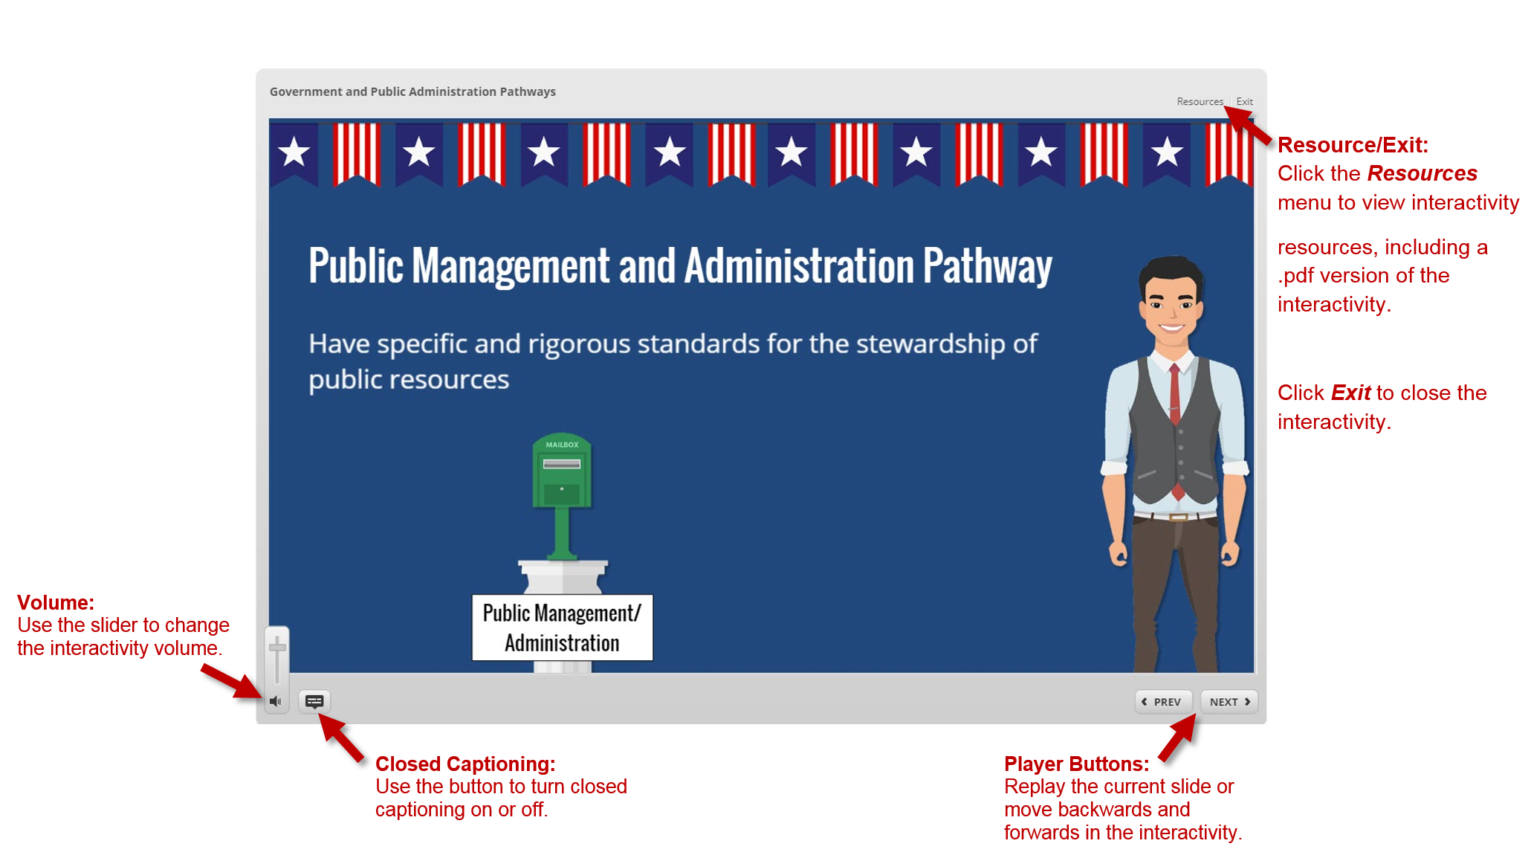

## Menu Slides

Some interactivities include a menu slide. Click each menu option to learn more. You can return to the menu by clicking the ***Prev*** button or using the ***Menu*** button.

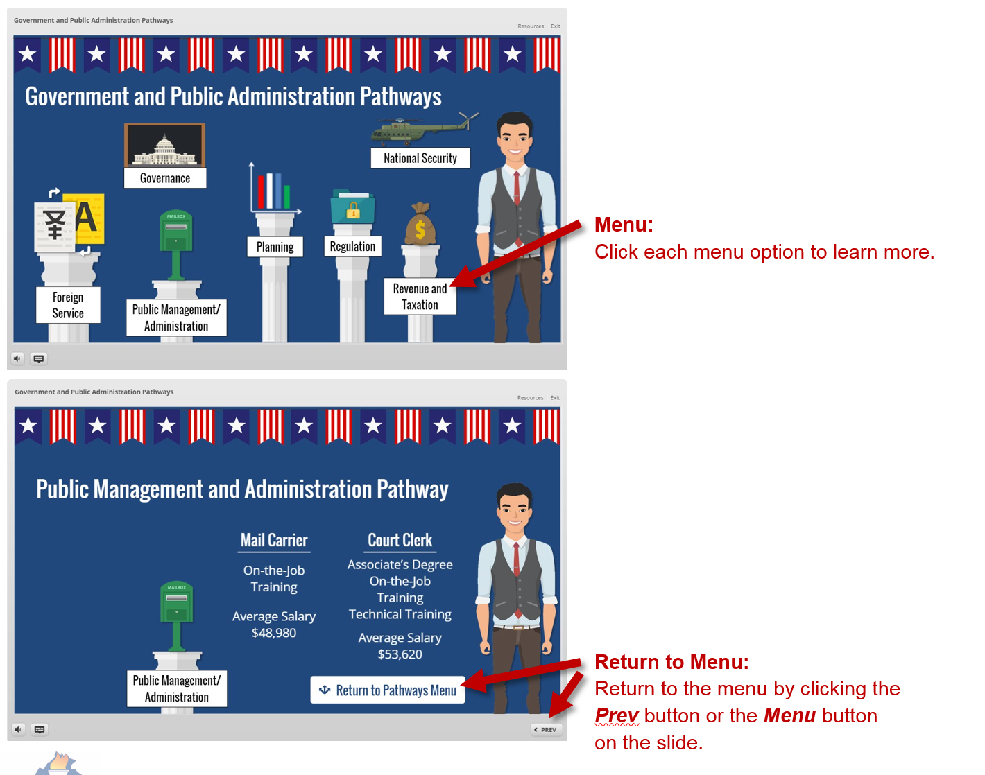

## Interactive Slides

Interactivities often include interactive slides with clickable textboxes, images, or icons that reveal additional information. Some interactivities may include drag-and-drop or sliders. Follow the directions on these slides to move forward through an interactivity.

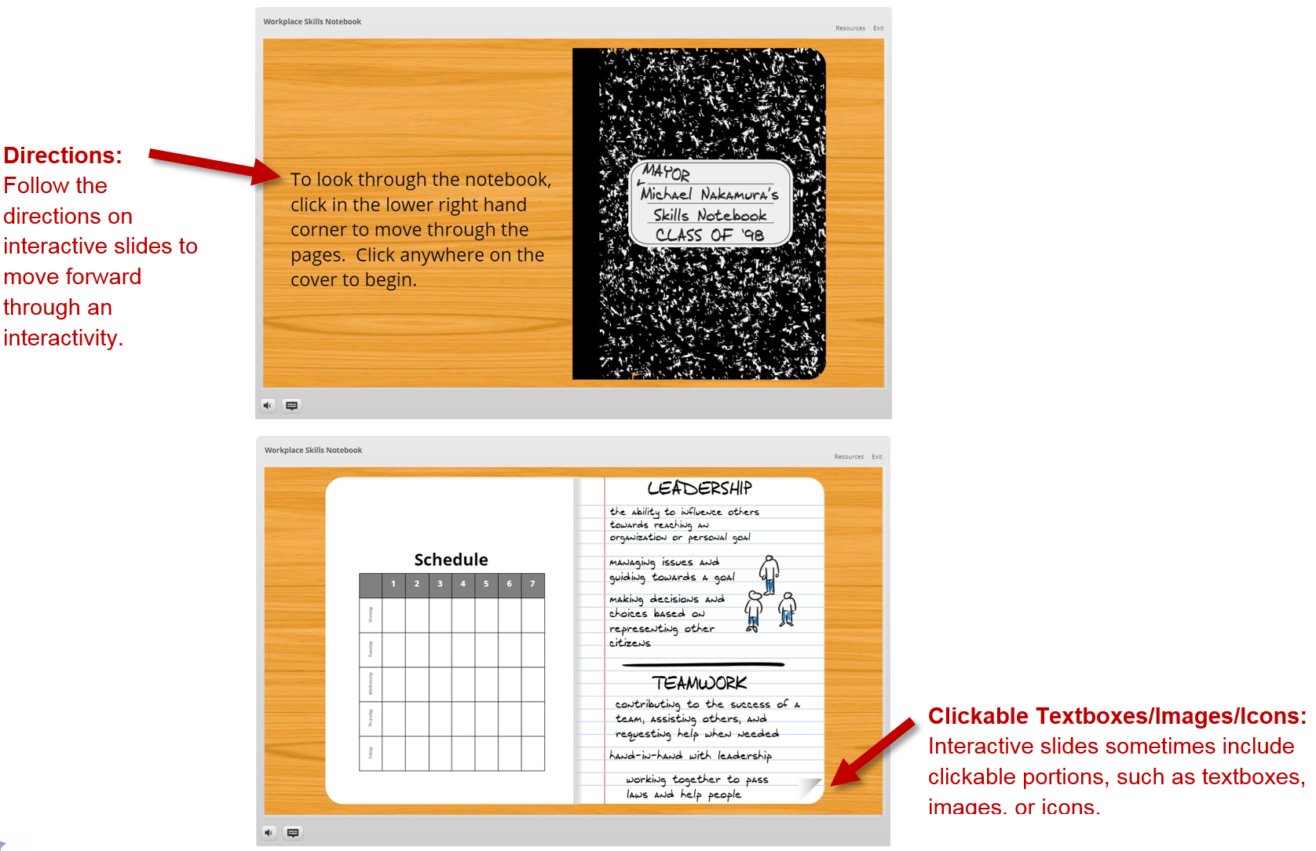

## How to Exit an Interactivity

All interactivities are set to open in a new browser tab. To exit an interactivity, simply close the browser tab by clicking the “**x**” located in the corresponding tab or clicking ***Exit*** in the player.

