# Middle School Career Investigations: Tips for Viewing and Navigating Quiz Interactivities

In each topic of the course, you will find a quiz interactivity. Each quiz interactivity follows a similar layout. Audio is not included in quiz interactivities. This document provides tips for viewing and navigating quiz interactivities.

## Instructions Slide

All quiz interactivities begin with an instructions slide. Read the instructions carefully. You have three attempts to receive a score of 75% or above. Make sure that you save or print your certificate after each attempt. Enter your first name and last name in the field provided. Then, click the ***Next*** buttonto start the quiz.

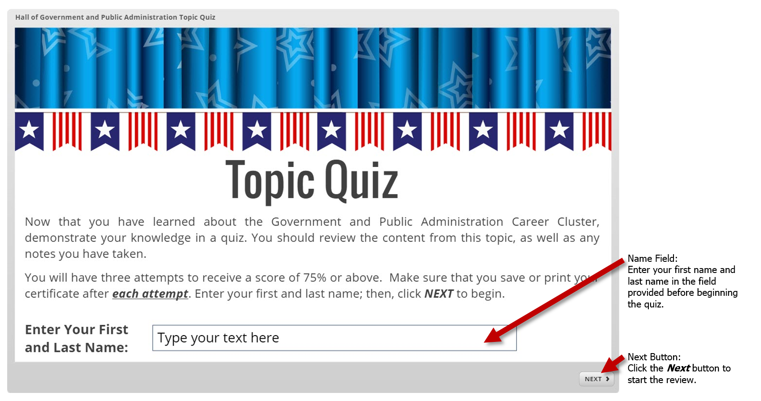

## Submitting an Answer

A variety of question types are used in topic quiz interactivities. Read the question or statement on the slide. Next, answer the question and click the ***Submit*** button to submit your answer. The example shown below is a multiple choice question.

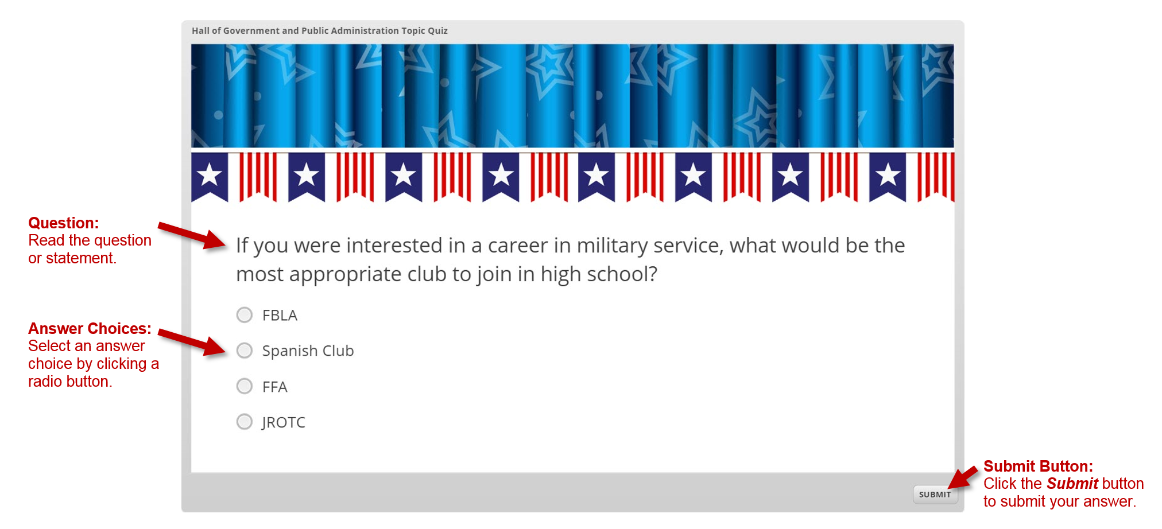

## Other Question Types

These examples include drag-and-drop, drop-down, and true/false questions.

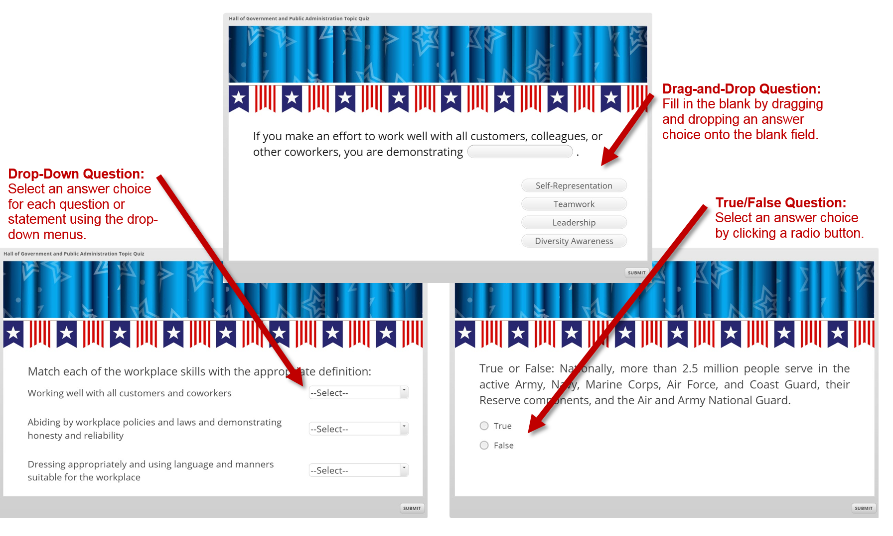

## The Results Slides

All quiz interactivities include a results slide**,** which appears when all of the questions have been answered. The results slide contains your score, a message about whether you received a passing score of 75% or above, and a reminder to print or save your results. Click the ***Print Results*** button to print or save your ***Quiz Completion Certificate***.

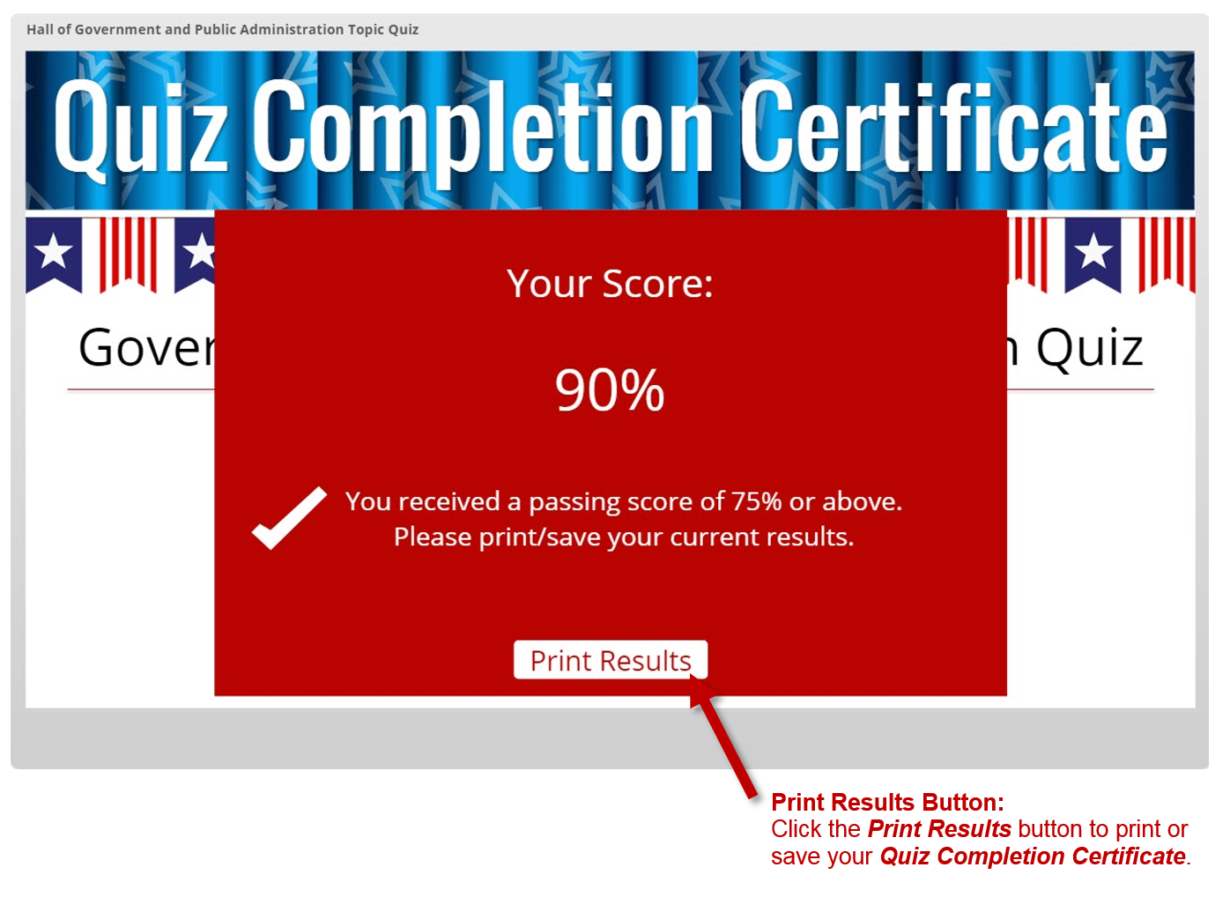

## How to View and Print the Quiz Completion Certificate

Upon clicking the ***Print Results*** button, you will be shown your ***Quiz Completion Certificate***. Make sure that you save or print your certificate after each attempt so that you can submit your highest score to your instructor. Three options for printing/saving your certificate include the following:

1. Print the ***Quiz Completion Certificate*** to submit it in-person or scan the printed page to create a digital copy.
2. Print or save the ***Quiz Completion Certificate*** as an **Adobe® PDF** file.
3. Take a screen shot of the ***Quiz Completion Certificate*** to save it as an image file.

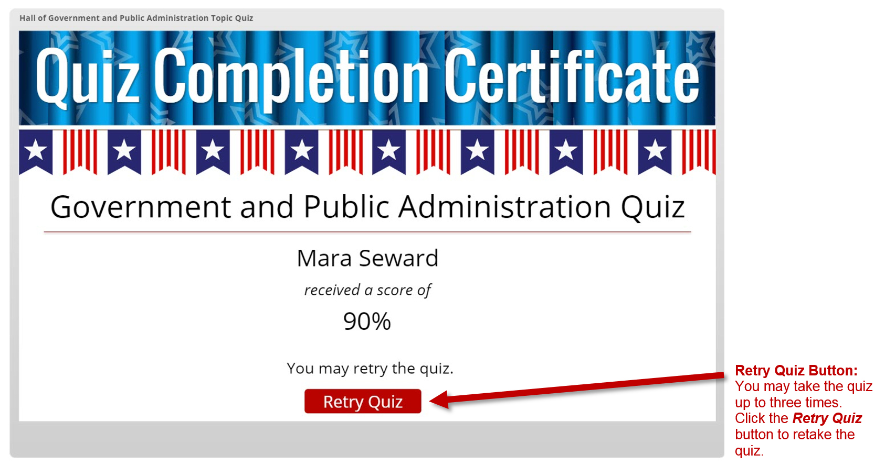

## How to Exit a Quiz Interactivity

All quiz interactivities are set to open in a new browser tab. To exit a topic quiz interactivity, simply close the browser tab by click the “**x**” located in the corresponding tab.

