Using your knowledge of relations and functions, solve each problem shown below. Follow the instructions for each portion, answer all of the questions, and make sure to show all of your work. Answer all of your work in the blank spaces provided.
For Problems 1-2: Answer each question.
- Create a relation with a domain of {−3, 1, 5, 9}.

- Represent the relation that you created in Problem 1 in another form.

For Problem 3: Answer the questions and explain your reasoning.

- Is the relation a function?
  - Is the image below a function? Circle One: Yes or No
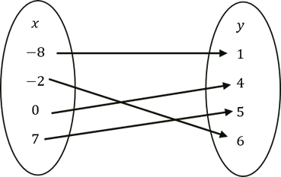
  - Explain your reasoning.

  - Is the image below a function? Circle One: Yes or No
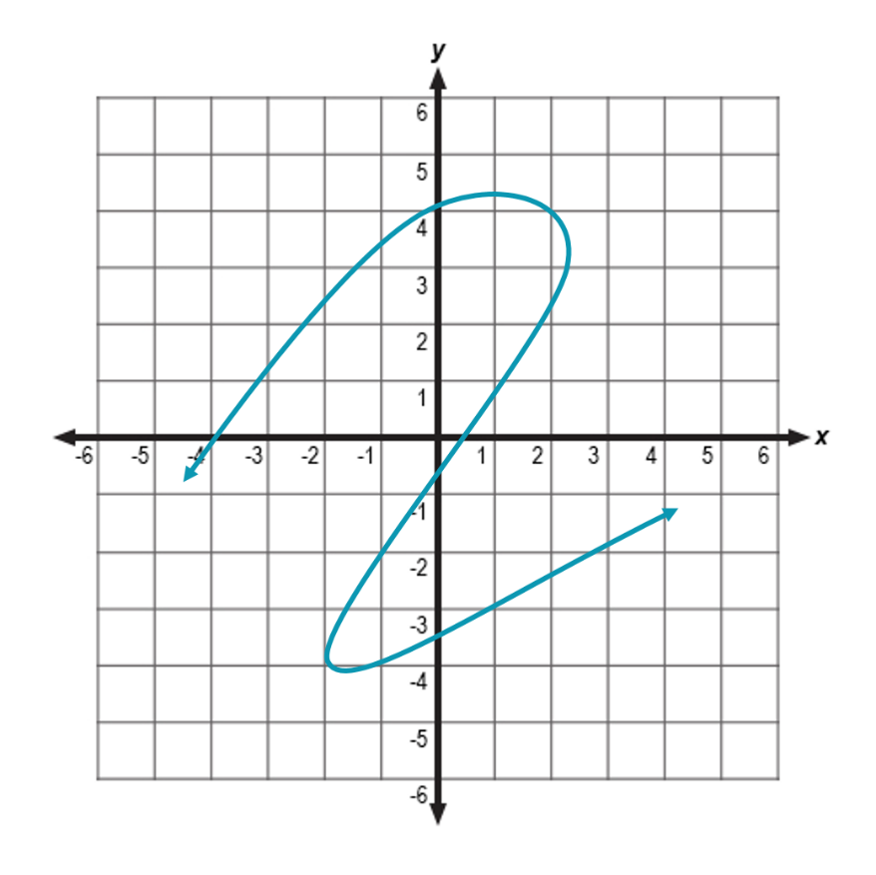
  - Explain your reasoning.

  - Is the set of ordered pairs below a function? Circle One: Yes or No
  - Explain your reasoning.

  - Is the image below a function? Circle One: Yes or No
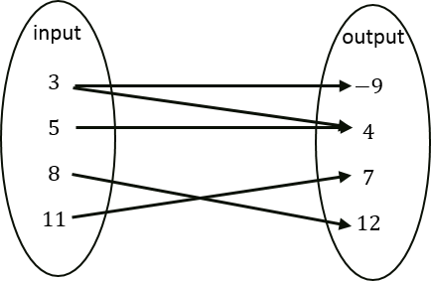
  - Explain your reasoning.

For Problem 4: Use the table to answer the question.
x | y

- The table models the relationship between corresponding -values and -values. Describe how to determine the -value for each corresponding -value.

For Problem 5: Define the domain and range of each function.
- What is the domain and range of each function?

Domain:

Range:

Domain:

Range:

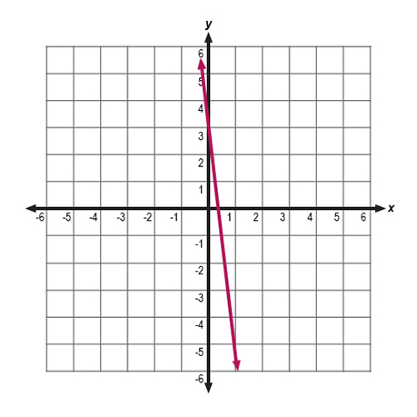
Domain:

Range:

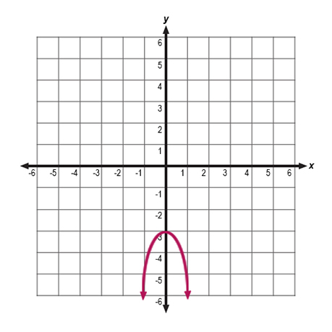
Domain:

Range:

For Problem 6: Read the scenario and answer the questions.
- Tai volunteered to sell tickets to an upcoming school play. There are a total of tickets available for a cost of each.
Let represent the total amount of money she receives from ticket sales and represent the number of tickets.
  - Write a function to represent the total amount of money Tai receives from ticket sales.

  - What is the domain of the function? Explain your reasoning.

