Using your knowledge of finding function values for elements of the domain, solve each problem shown below. Follow the instructions for each portion, answer all of the questions, and make sure to show all of your work.
For Problem 1: Explain the error in the work shown below. Then, rework the problem correctly.
- Given: Find

sdadasd

- Explain the error in the work.

- Rework the problem correctly.

For Problem 2: Find the range for the given.
- Given: find the range of for the domain .

For Problem 3: Use the graph to find the solution.
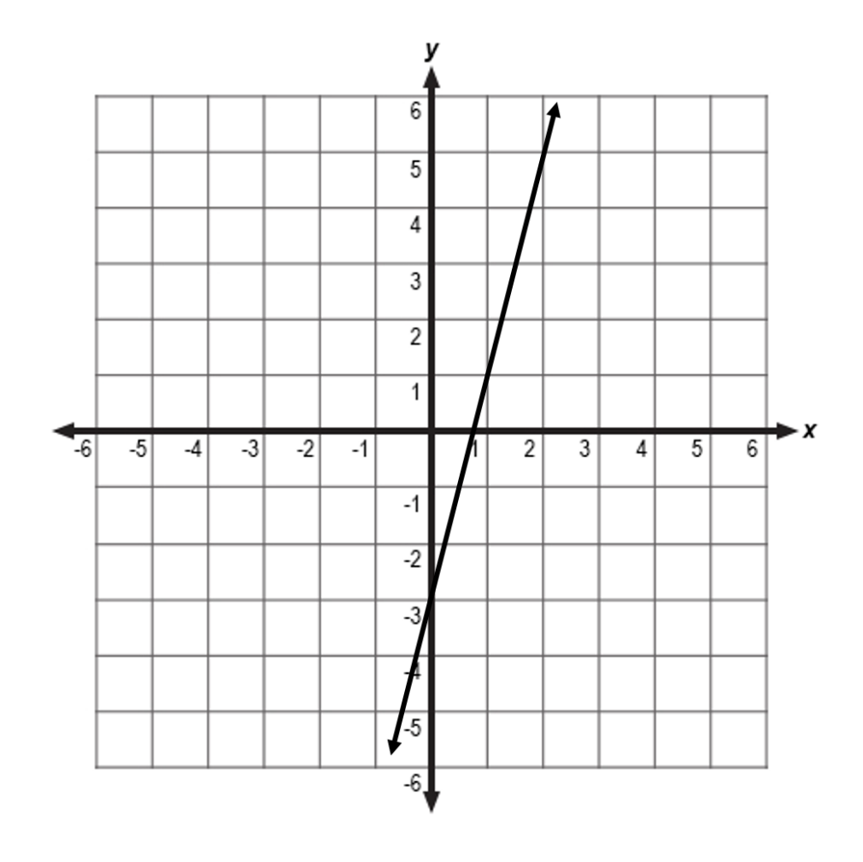
- Given the graph of ,

For Problem 4: Read the scenario and answer the question.

- During a local high school football game, the height feet of a football after seconds can be represented by the function . Find h (2.5) and explain its meaning.

For Problem 5: Use the table to answer find the solutions.

1

- Given the quadratic function is represented by the table above:

  - _________________________

  - _________________________

  - _________________________

For Problem 6: Find the range for the given.

- Given: , find the range of for the domain .

