1. Solve the following systems of linear equations by elimination.

A) 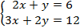 _______________

B) 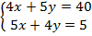 _______________

2. Solve the following systems of linear equations by substitution.

A) 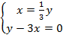 _______________

B) 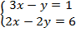 _______________

3. Solve for the following systems of linear equations by graphing. Provide a rough sketch of the graph of each system.

A) 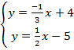 _______________

B) 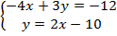 _______________

4. Solve the following system of linear equations by substitution. Then confirm your answer by graphing the system.

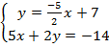 _______________

5. How does the graph of a system of linear equations with one solution differ from the graph of a system of linear equations with infinite solutions?

_________________________________________________________________________________________________________

_________________________________________________________________________________________________________

_________________________________________________________________________________________________________

_________________________________________________________________________________________________________

_________________________________________________________________________________________________________

_________________________________________________________________________________________________________

_________________________________________________________________________________________________________

