Answer each question in the blank spaces provided making sure to show all of your work.

1. During the kickoff at a local high school football game, a football is placed onto a tee to a height of 0.125 feet above the ground. The football is kicked with an initial velocity of 80 feet per second.

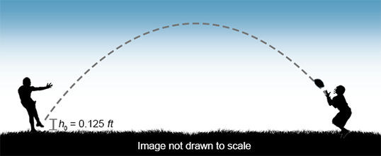

* 1. Write an equation that best models this scenario.
  2. If the ball is caught at a height of 5 *ft*, approximately how long did it remain in the air? Round to the nearest hundredth of a second.

1. The length of a rectangular-shaped patio is 3 feet shorter than four times its width.

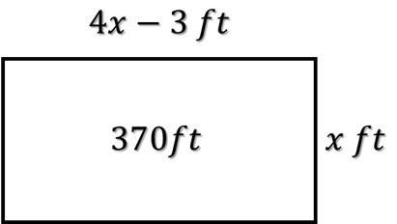

*370 ft2*

* 1. Write an equation to represent the area of the patio.
  2. If the patio has an area of 370 *ft* 2, find the dimensions of the patio.

1. A rectangular-shaped dining room table is modeled by the figure given below.

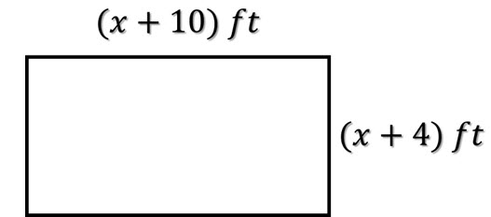

* 1. Write an equation to represent the area of the dining room table.
  2. If the area of the table is 112 *ft* 2, what are the dimensions of the dining room table?