**For problems 1 – 3: Solve for y. Show detailed work.**

1. _____________

2. _____________

3. _____________

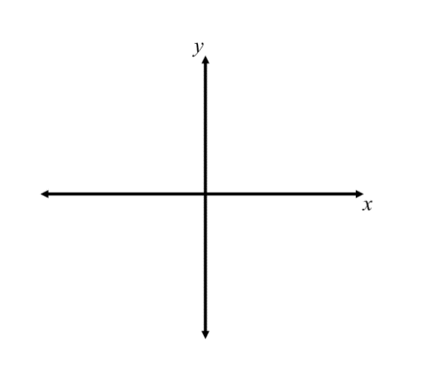**For problems 4 – 6: Use the graphing calculator to graph each inequality. Show detailed work. Provide a rough sketch of each graph.**

4. _____________

5. _____________

6. _____________

**For questions 7 –10: Refer to the inequality shown in the graph below.**

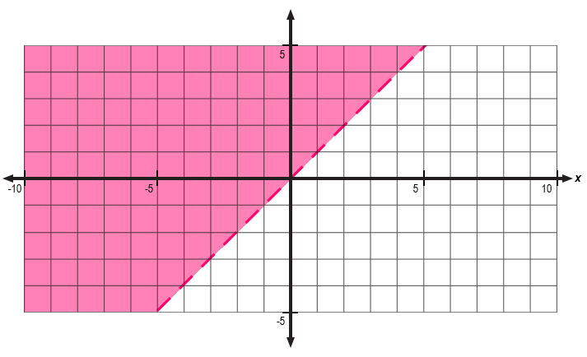

Given the inequality shown in the graph:

7. Describe the location(s) on the graph where you can find solutions.

_________________________________________________________________________________________________________

_________________________________________________________________________________________________________

8. Plot two points that are included in the solution set. Label the points A and B.

9. Describe the location(s) on the graph where you **cannot** find solutions.

_________________________________________________________________________________________________________

_________________________________________________________________________________________________________

10. Plot two points that are **not** included in the solution set. Label the points C and D.

**For question 11: Refer to the inequality given below.**

11. Choose each of the following points that is a solution to the given inequality. Show work to justify your answer.

A) $(5, 1)$

B) $(-3, 2)$

C) $(0, 4)$

D) $(-1, -5)$