Use your knowledge of systems of linear inequalities to provide responses. Use complete sentences and math vocabulary. Show your work where appropriate.
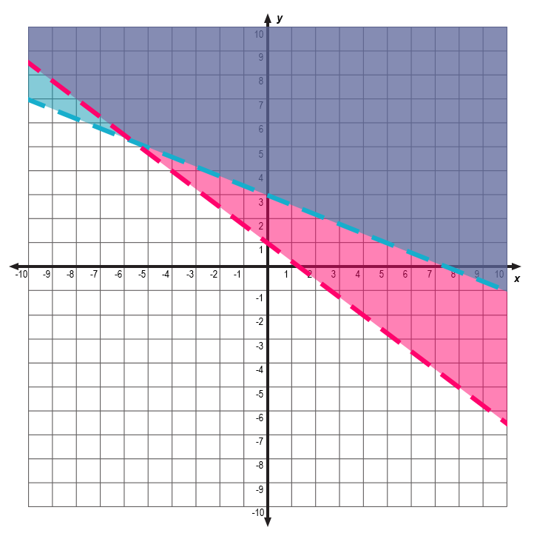
1. Determine if each of the following points is a solution to the system of inequalities shown above. Explain your reasoning.

A) _____________________________________________________________________________________

B) _____________________________________________________________________________________

C) _____________________________________________________________________________________

2. Plot two points that are included in the solution set of the system of inequalities. Label the points A and B.

3. Plot two points that are not included in the solution set of the system of inequalities. Label the points C and D.

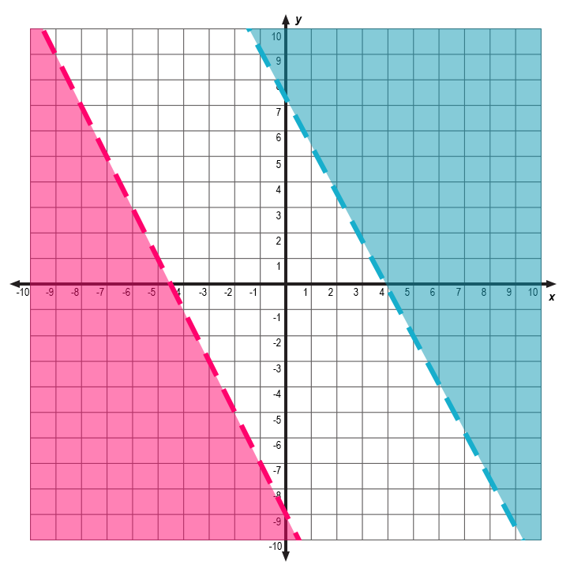
4. The system of linear inequalities shown in the graph above has no solutions. Analyze the graph of the system. Explain why it has no solutions.

_________________________________________________________________________________________________________

_________________________________________________________________________________________________________

5. Is a solution to the following system of inequalities? Show work to verify algebraically. Then, provide an explanation below.







