Part I: Explain the transformations of given by each equation.

Equation | Description
1.
2.
3.
4.
5.
6.
7.

Part II: Graph each line after the given transformations of .
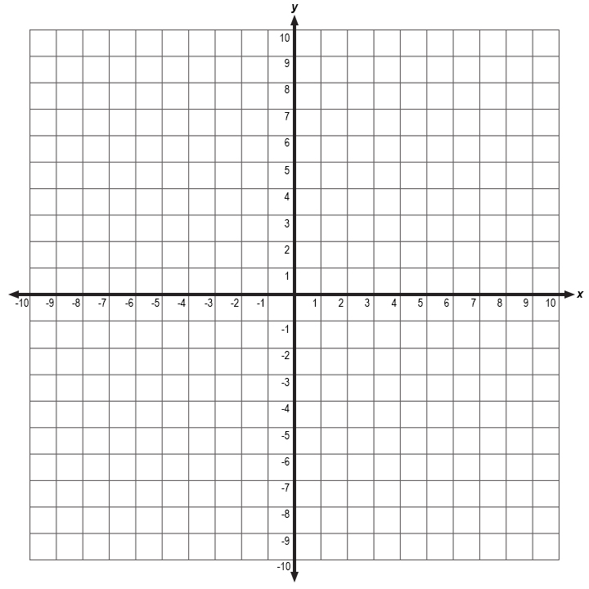
8. A translation 4 units down

9. A stretch by a factor of 3

10. A reflection and
a translation unit up

