Using your knowledge of determining the slope of a line, solve each problem shown below. Follow the instructions for each portion, answer all of the questions, and make sure to show all of your work. Answer all questions in the blank space provided.

For problems 1-9: Determine the slope of each line represented by a graph or an equation.

- 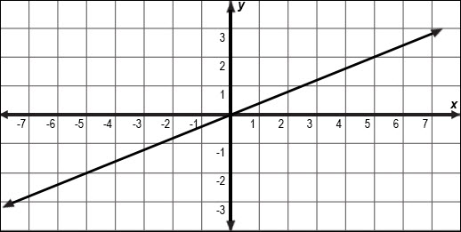

- 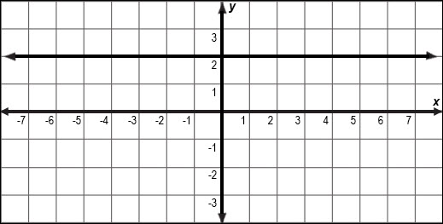

- 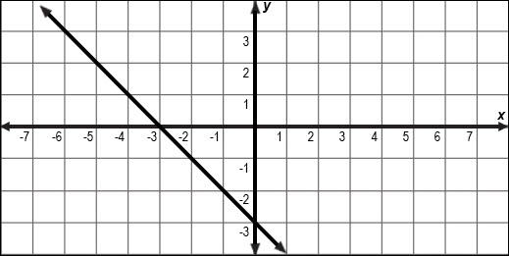

- 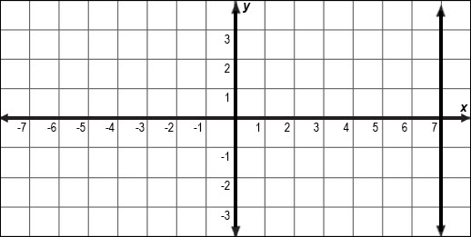

For problems 10 through 12, use the slope formula to determine the slope of the line that passes through each pair of points.

- and

- and

- and

For problem 13, use the given information to determine the rate of change.

- Each week, Adams deposits money into his savings account. The graph below models the scenario.

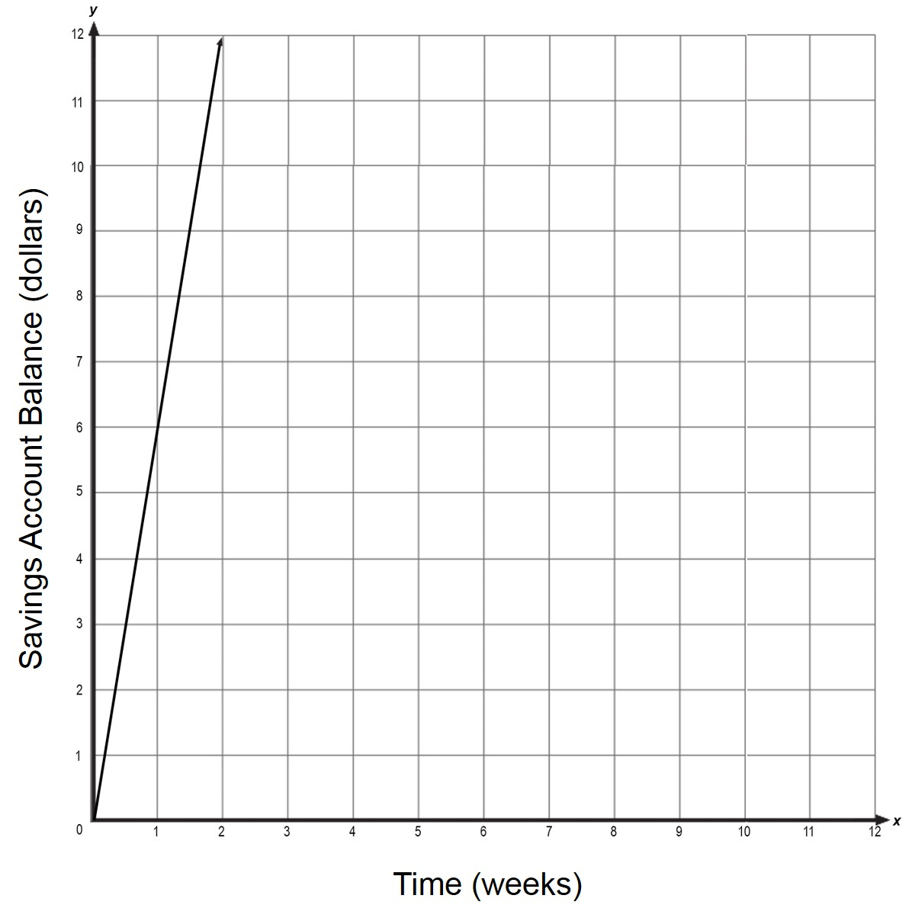
  - How much money does Adam deposit each week?

  - How did you determine the answer?

  - Use an alternate strategy to determine the amount of money Adam deposits each week.

