Using your knowledge of parallel and perpendicular lines, solve each problem shown below. Follow the instructions for each portion, answer all of the questions, and make sure to show all of your work. Answer all questions in the blank space provided.
For problems 1 through 5, write an equation of the line that is parallel to the given line and passes through the given point.

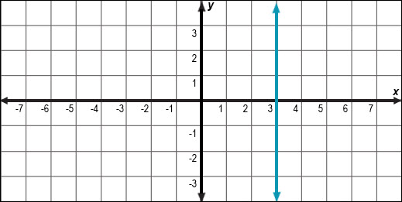

- ;

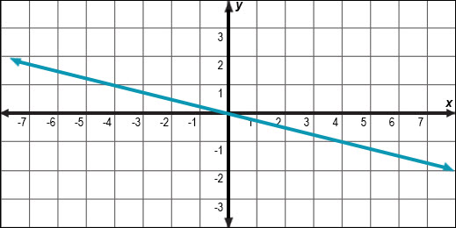

- ;

- ;

For problems 6 through 10, write an equation of the line that is perpendicular to the given line and passes through the given point.

- ;

- ;

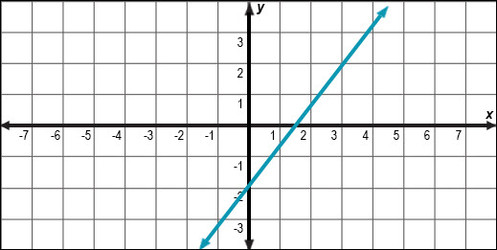

- ;

- ;

For problem 11, use the given information to write a linear equation.
- The earnings of part-time employees at a local computer repair store can be modeled by the equation , where represents the number of hours worked and represents the total earnings. Jasmine works at a competing store where she earns the same hourly rate. After working for hours, she earned . Write an equation to represent Jasmine’s total earnings.

