**1.1 Activity**Part 1: Match the function notation with the correct equation. To do this, copy/paste the answer into the Rewritten with Function Notation column.

Part 2: Match the graph of the function with the correct equation. To do this, copy/paste the graphic into the Graph of Function column.









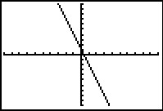

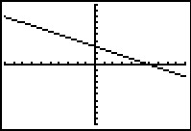

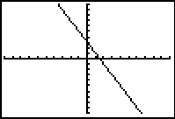

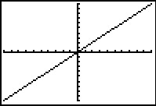

|  |  |  |
| --- | --- | --- |
| **Equation** | **Rewritten with Function Notation** | **Graph of Function** |
| $$y = x$$ |  |  |
| $$3x + y = 1$$ |  |  |
| $$2x + 4y = 12$$ |  |  |
| $$6x + 3y = 9$$ |  |  |