**1.3.1 Activity**

Match the graph with the correct domain and range. To do this, copy and paste the graph into the column, “Graph.”

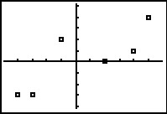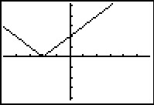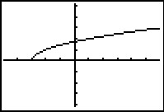

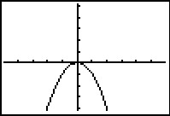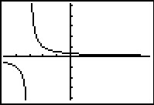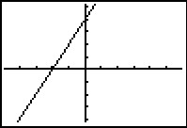

|  |  |  |
| --- | --- | --- |
| **Graph** | **Domain** | **Range** |
|  | Domain: All real numbers | Range: y ≤ 0 |
|  | Domain: {-4, -3, -1, 2, 4, 5} | Range: {-3, 0, 1, 2, 4} |
|  | Domain: All real numbers, x ≠ -3 | Range: All real numbers, y ≠ 0 |
|  | Domain: x ≥ -3 | Range: y ≥ 0 |
|  | Domain: All real numbers | Range: y ≥ 0 |
|  | Domain: All real numbers | Range: All real numbers |