# Assignment 11.1 Right Triangle Trigonometry

1. Find the hypotenuse and evaluate the six trigonometric functions of the angle  .

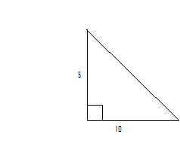

θ

1. The lengths of the sides of a right triangle are 5 cm, 12 cm, and 13 cm. Sketch the triangle. Let represent the angle that is opposite the side whose length is 5 cm. Evaluate the six trigonometric functions of .
2. Find the missing side length x and y.

x

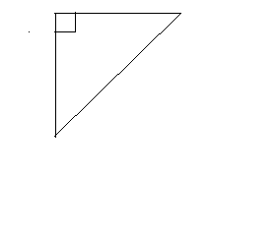





y

Use your calculator to evaluate the trigonometric function. Round your answer to four decimal places.

1. 
2. 
3. 

Solve  using the diagram and the given measurements. 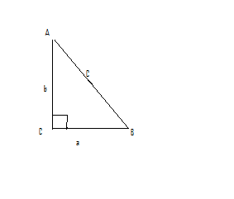

1. 
2. 
3. 
4. 
5. A gangplank of a ship is 10 feet long and can be set at a maximum safe angle of elevation of . What is the closest a ship can come to the dock using this gangplank?