# Activity 11.4 Inverse Trigonometric Functions

Evaluate the expression without using a calculator. Give your answer in both radians and degrees.

1.  2.  3. 

Find the measure of the angle . Round to three significant digits.

4. 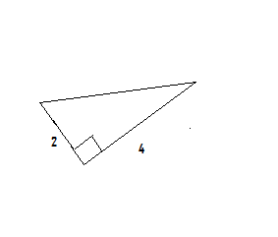 5.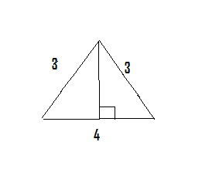





Use a calculator to evaluate the expressions in both radians and degrees. Round to three significant digits.

6.  7.  8.  9. 

Use a calculator to solve each equation for .

10.  11. 

12. A dump truck has a 10 foot bed. When tilted at its maximum angle, the bed reaches a height of 7 feet above it original position. What is the maximum angle  that the truck bed can tilt?