# Activity 11.5 The Law of Sines

Solve using the Law of Sines.

1. 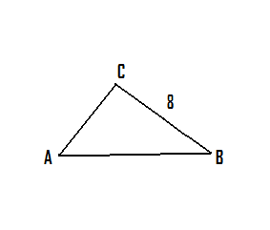 2.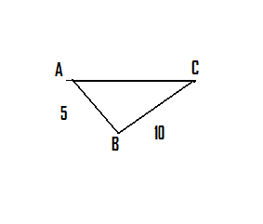





Solve . It is possible that some of the problems have two solutions.

3. 

4. 

5. 

6.A reservoir supplies water through an aqueduct to Springfield, which is 15 miles from the reservoir at a  angle southeast of the reservoir. A pumping station at Springfield pumps water to Centerville, which is 7.5 miles due east of Springfield. Plans have been made to build an aqueduct directly from the reservoir to Centerville. How long will the new aqueduct be?