# TOPIC 12-1 Independent Practice

1. Match each function to its graph.

1. 

2. 

3. 

4. 

5. 

6. 

7. 

8. 

GRAPHS:

­­­_____ 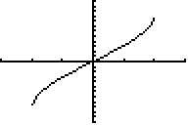

­­­_____ 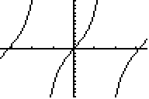

_____ 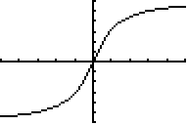

_____ 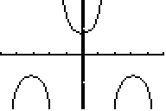

_____ 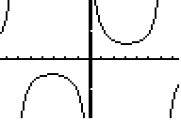

_____ 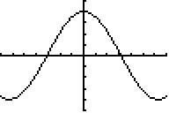

_____ 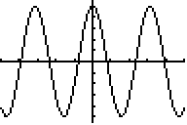

_____ 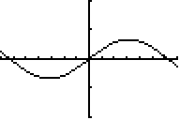

1. For each function, if applicable, identify the function’s period, amplitude, minimum, maximum, and vertical asymptotes.

1. 

2. 

3.   
  
4. 