2.2.1 Activity

IDENTIFY LINEAR FUNCTIONS ACTIVITY

For each function, depicted below by both its equation and graph, (a) determine whether the function is linear or nonlinear, and (b) provide your reasons:

FUNCTIONS:

1.

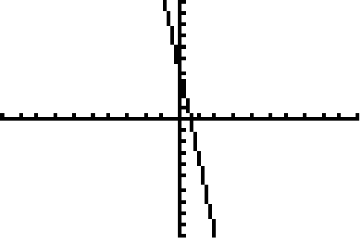

**

Linear or nonlinear? Why?

________________________________________________________________________________________________________________________________________________

2.

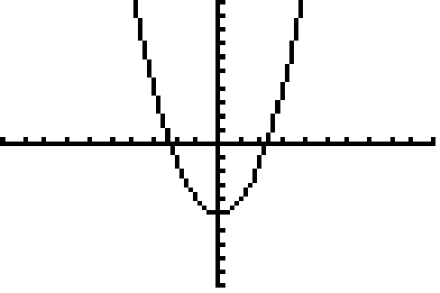

**

Linear or nonlinear? Why?

________________________________________________________________________________________________________________________________________________

3.

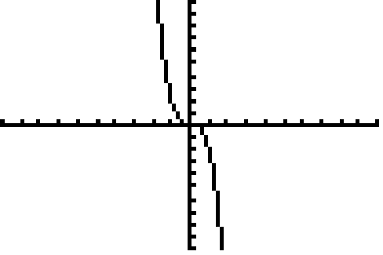

**

Linear or nonlinear? Why?

________________________________________________________________________________________________________________________________________________

4.

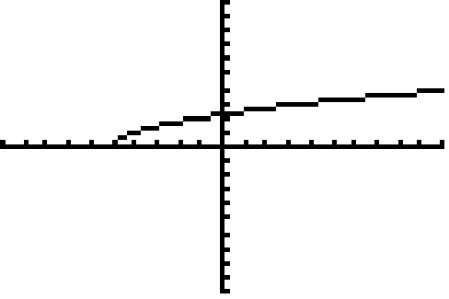

**

Linear or nonlinear? Why?

________________________________________________________________________________________________________________________________________________

5.

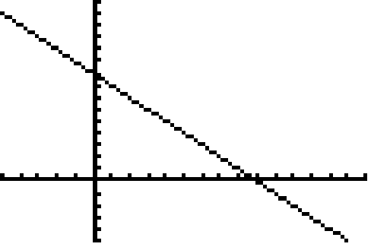

**

Linear or nonlinear? Why?

________________________________________________________________________________________________________________________________________________

6.

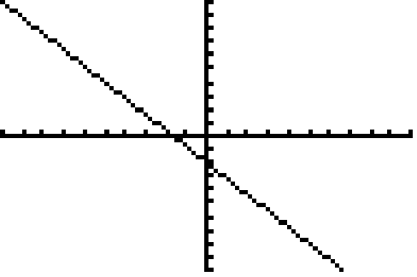

**

Linear or nonlinear? Why?

________________________________________________________________________________________________________________________________________________

7.

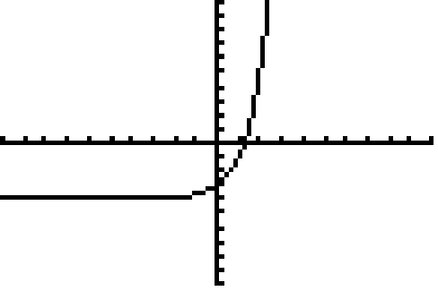

**

Linear or nonlinear? Why?

________________________________________________________________________________________________________________________________________________

8.

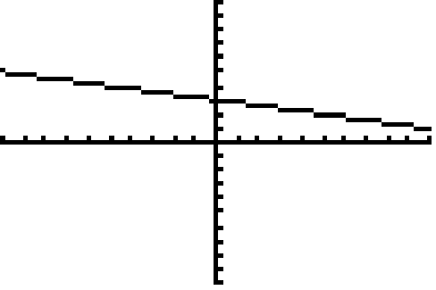

**

Linear or nonlinear? Why?

________________________________________________________________________________________________________________________________________________

9.

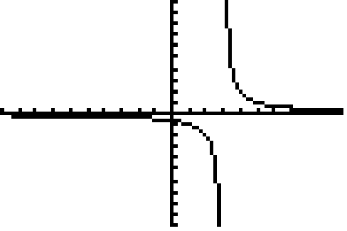

**

Linear or nonlinear? Why?

________________________________________________________________________________________________________________________________________________