**2.2.1 Activity**

**LINEAR CHARACTERISTICS ASSESSMENT**

Given the various linear criteria described for each problem, the student (i) identifies the correct linear equation and (ii) selects the correct graph of the equation from the lists on the pages that follow.

CRITERIA:

1. Slope of 3, passing through (0,-2).

EQUATION: _____ GRAPH: _____

1. Slope of -6, passing through (5,-2).

EQUATION: _____ GRAPH: _____

1. Containing the points (-4,5) and (2,-7).

EQUATION: _____ GRAPH: _____

1. Containing the points (7,5) and (-8,-4).

EQUATION: _____ GRAPH: _____

1. Parallel to the line **and containing the point (6,-2).

EQUATION: _____ GRAPH: _____

1. Parallel to the line **and containing the point (1,1).

EQUATION: _____ GRAPH: _____

1. Perpendicular to the line ** and containing the point (-3,-2).

EQUATION: _____ GRAPH: _____

1. Perpendicular to the line ** and containing the point (6,2).

EQUATION: _____ GRAPH: _____

1. Having *x-intercept* at 5 and *y-intercept* at -2.

EQUATION: _____ GRAPH: _____

1. Having *x-intercept* at -3 and *y-intercept* at 8.

EQUATION: _____ GRAPH: _____

EQUATION LIST:

A. **

B. **

C. **

D. **

E. **

F. **

G. **

H. **

I. **

J. **

GRAPH LIST:

A. 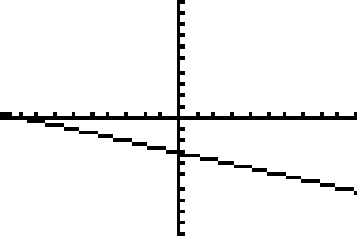

B. 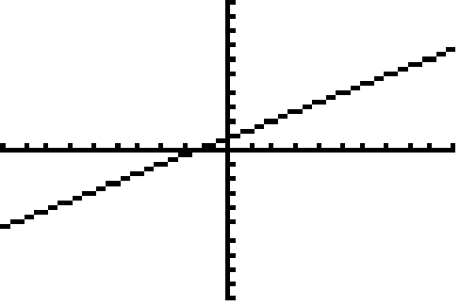

C. 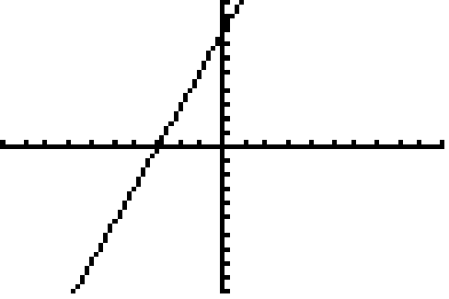

D. 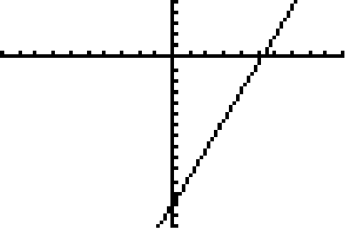

E. 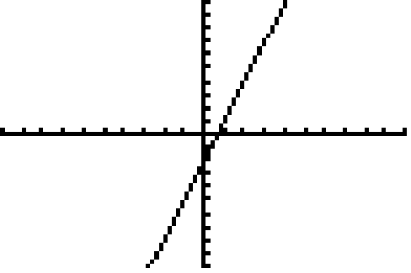

F. 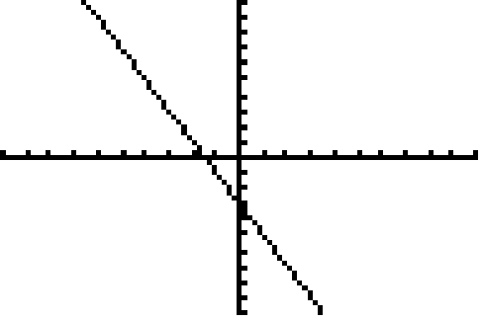

G. 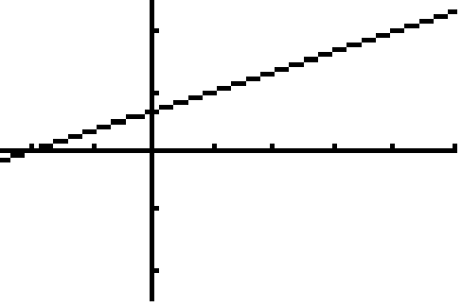

H. 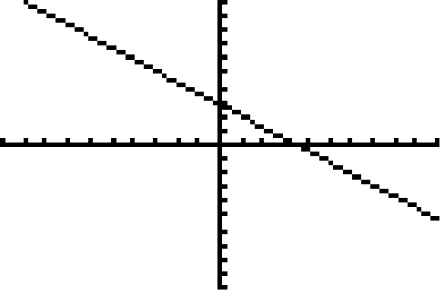

I. 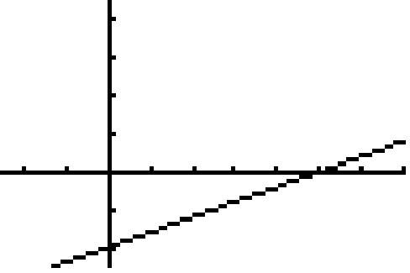

J. 