**2.2.1 Activity**

**CORRELATION ACTIVITY**

For each table of values or scatterplot below, select the appropriate correlation description form the following list:

1. Strong positive correlation
2. Weak positive correlation
3. Strong negative correlation
4. Weak negative correlation
5. No correlation

FUNCTIONS:

1. _____

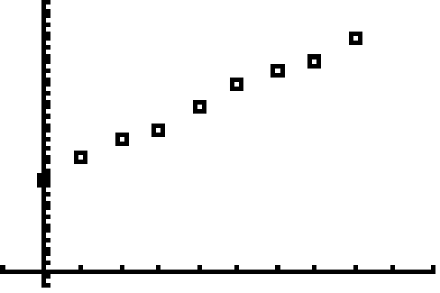

2. _____

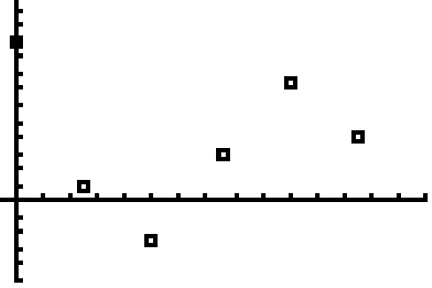

3. _____

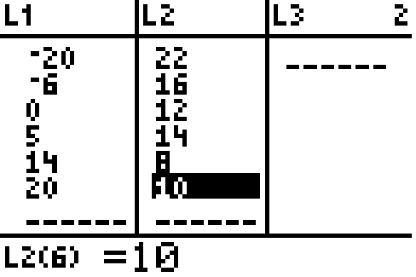

4. _____

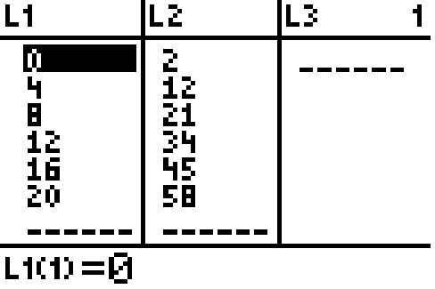

5. _____

