**2.2 Warm-Up**

In Topic 2.1, we examined four distinct expressions of linear functions:

* Table of values (or solutions)
* Graph
* Equation (or “rule”) in mathematical symbols
* Word problem

A single linear relationship may be expressed in any, or all, of these means.

Consider a waiter at a restaurant: The waiter is paid a flat, weekly salary of $100.00, and 80 % of all the tips received (20% of the tips are reserved for the staff setting and cleaning the tables).

Using this word problem: (a) determine the equation of the function for the total weekly pay received by the waiter; (b) create a table of values; (c) plot selected values from your table; and (d) graph the function.

**SOLUTIONS**:

1. Let x be the amount of tips in any week, in dollars. Eighty percent is represented as a decimal as .8. So the total weekly pay for the waiter is .

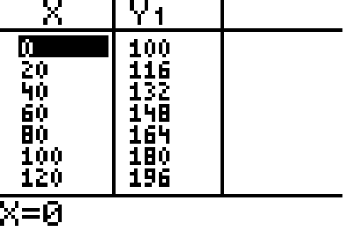

c.

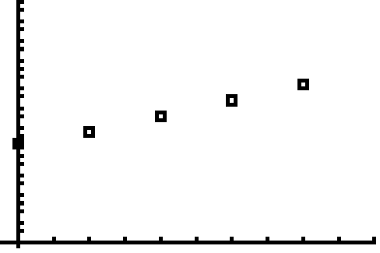

d.

