**3.1 Activity**

1. If the graph of the line is translated right 5 units and down 3 units, what is the equation of the new line?
2. How does the graph of compare with the graph of ?
3. If , find:
4.  b)  c) 
5. Write an equation of each line.
6. The line translated down 3 units
7. The line translated right 2 units
8. The line translated up 4 units and left 1.5 units
9. Now that you have studied the translations of a linear function, let’s apply that concept to a function that is not linear. The graph of is shown below. Write an equation for each of the given graphs that shows the translation using the form. (For example, if the graph appears to have moved up 1 unit, you would write the equation as .)

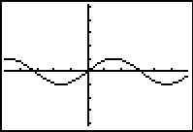

1. 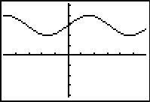
2. 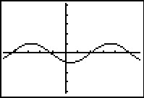
3. 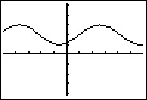
4. Jeannette and Keagan collect data about the length of a rope as knots are tied in it. The equation that fits their data is , where *x* represents the number of knots and *y* represents the length of the rope in centimeters. Mitch had a piece of rope cut from the same source. Unfortunately he lost his data and can remember only that his rope was 47 centimeters long after he tied 3 knots. What equation describes Mitch’s rope?