**3.2.1 Activity**

Write an equation for each parabola. Each parabola is a translation of the graph of the parent function .

1. 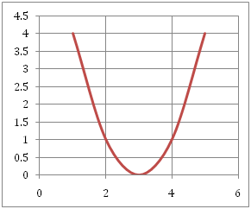
2. 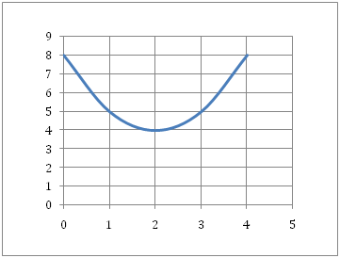
3. Use the graph for exercise 1 and give the vertex point and the equation for the line of symmetry.
4. Use the graph for exercise 2 and give the vertex point and the equation for the line of symmetry.
5. Describe what happens to the graph of in  the following situations.  
   (Hint: For c and d you will need to make the substitution for y and then solve the equation for y before describing the translation. See the following example.)

Example: y is replaced with y -3

Solution: 

The graph is translated up 3 units.

1. x is replaced with 
2. x is replaced with 
3. y is replaced with 
4. y is replaced with 
5. Application: Use your graphing calculator to help you solve the following problem.

The table of values below compares the number of teams in a peewee baseball league and the number of games required for each team to play every other team twice (once home and once away).

|  |  |  |  |  |
| --- | --- | --- | --- | --- |
| **Number of teams (x)** | **1** | **2** | **3** | **…** |
| **Number of games (y)** | **0** | **2** | **6** | **…** |

1. Continue the table out to 10 teams.
2. Graph the table in your calculator and describe the graph it produced.
3. The function for this problem can be described as a translation of the parent function. The translation is given as moving right 0.5 units and down .25 units. Write the algebraic model for this translation.
4. Using your model, find out how many games are required if there are 30 teams.