### Module 4 Real World Applications

1. The time it takes a pendulum to swing a full cycle is called its *period*. When measured in seconds, the period (P) of a pendulum is measured by the equation:  , where *L* is the length of the pendulum (in feet).

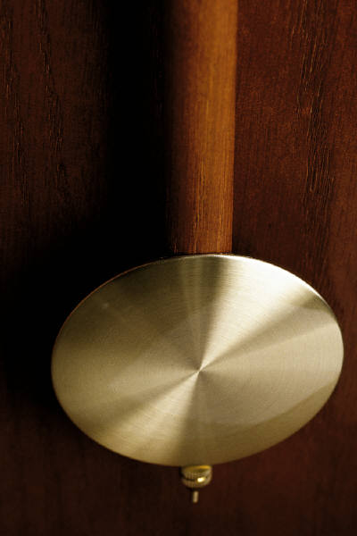

Find the period of a pendulum having a length of 8 feet.

1. At many amusement parks, there is a thrill ride based on the concept of a *rotor*. A rotor is a room in the shape of a cylinder; riders of a rotor stand against the wall of the cylinder and, when the rotor is rotating at a sufficient speed, the floor drops out and the riders stay fixed, pinned against the wall by the resulting centrifugal force.



The equation which determines the safe speed, *S* (in meters per second), necessary to keep the riders pinned to the walls is , where *r* is the radius of the rotor (in meters).

Determine the radius of a rotor having a safe speed of 24.75 meters/second.