# 5.2 Activity: Graphs of Polynomial Functions

For the graphs below, estimate the real roots of the polynomial function shown in the graph. Use a scale of 1 for the x-axis.

1. 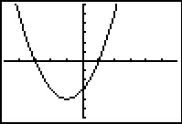
2. 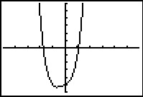

Use a graphing calculator to find the real roots of the following polynomial functions.

1. 
2. 
3. Graph . How many real zeros does this polynomial function have?

# Answers:

1. x = -3, 1
2. x≈ -1.67, 1
3. x = -.342, 1.2856
4. x = -1, 2, 3
5. 4