# 5.5 Activity: Solving Non-Linear Systems of Equations

State the solution of the system represented by each graph.

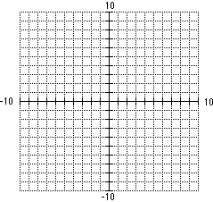

2.

Solve each system of equations.

3.  4. 

5. 