# 7-2 Activity

1. Completely factor the polynomials in the following rational functions.

1. 

2. 

3. 

4. 

5. 

1. Match each of the rational functions to its table of values:

1. _____ 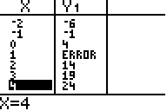

2. _____ 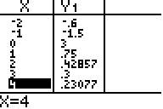

3. _____ 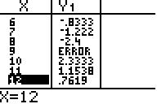

4. _____ 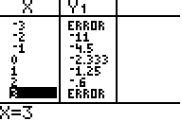

5. _____ 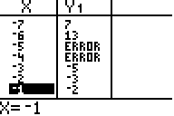

Functions:

a.  b. 

c.  d. 

e. 

1. Match each of the rational functions to its graph:

1. _____ 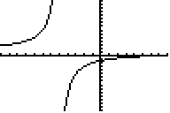

2. _____ 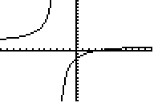

3. _____ 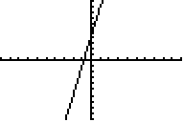

4. _____ 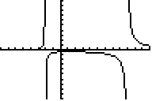

5. _____ 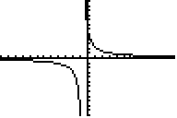

Functions:

a.  b. 

c.  d. 

e. 