# 8-2 Application

1. Functions and Graphs.

Match each function to its graph and, for each function, state its domain and range:

Graphs:

_____ 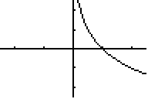

_____ 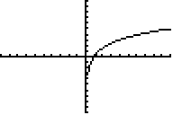

_____ 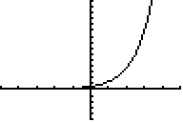

_____ 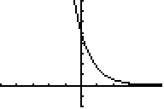

Functions:

1. : Domain: ________________________________

Range: _________________________________

1. : Domain: ________________________________

Range: _________________________________

1. : Domain: ________________________________

Range: _________________________________

1. : Domain: ________________________________

Range: _________________________________

1. Exponential v. Logarithmic Form.
2. Write each term in logarithmic form.
3.  _____________________
4.  _____________________
5. Write each term in exponential form.
6.  ______________________
7.  _______________________
8. Change of Base Formula.

Evaluate each logarithm to four decimal places using your calculator and the change of base formula:

1. ______________________
2. _______________________
3. _________________________
4. Solve the logarithmic equations.

1. 

2. 

3. 

4. 

1. Application.

For children of ages 5 through 13 years, the Ehrenberg relation correlates the height of the child, *h* (in meters), to the average weight, *W* (in kilograms) as follows:



1. What is the approximate height of a 12 year old child weighing 63 kilograms?
2. What is the average weight of a 10 year old child whose height is 1.25 meters?