Part I
Analyze the pedigree by answering the questions in the blank space provided.
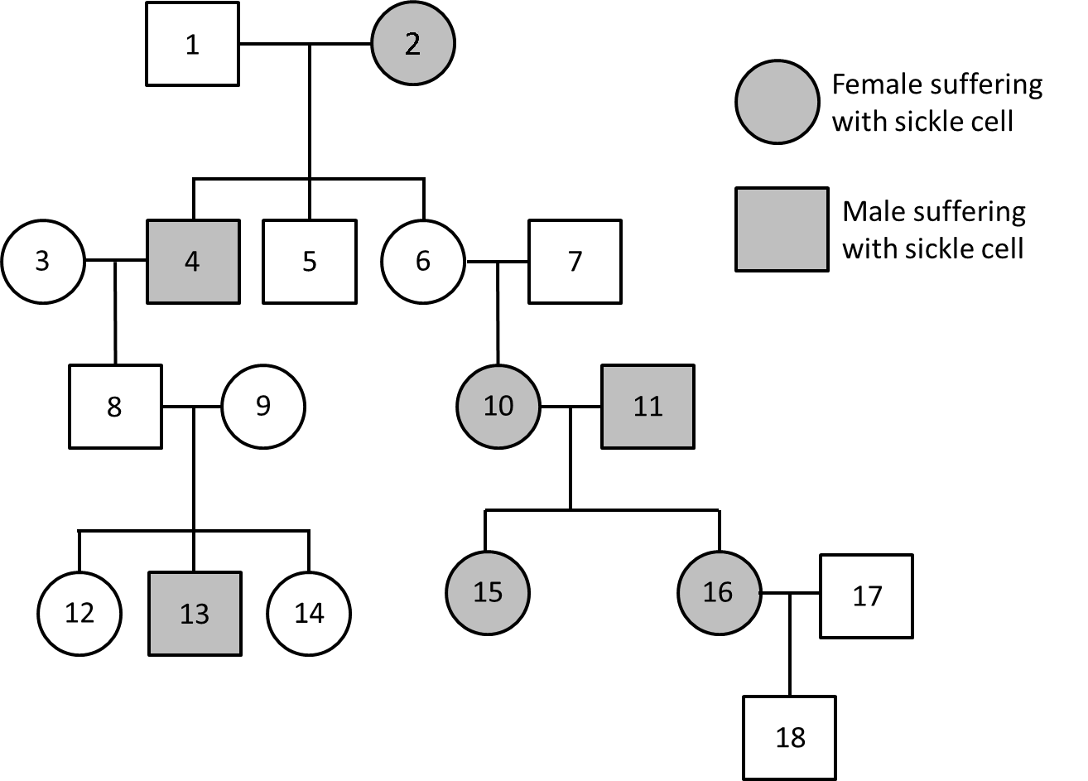
- What is the oldest member of this family?

- What is the youngest member of this family?

- What is the youngest female in this family?

- Explain how you know 10 and 11 are both affected by sickle cell?

- Who are members of the family that have no children?

- How many children did 8 and 9 have?
Part II
Analyze the pedigree by answering the questions in the blank space provided.
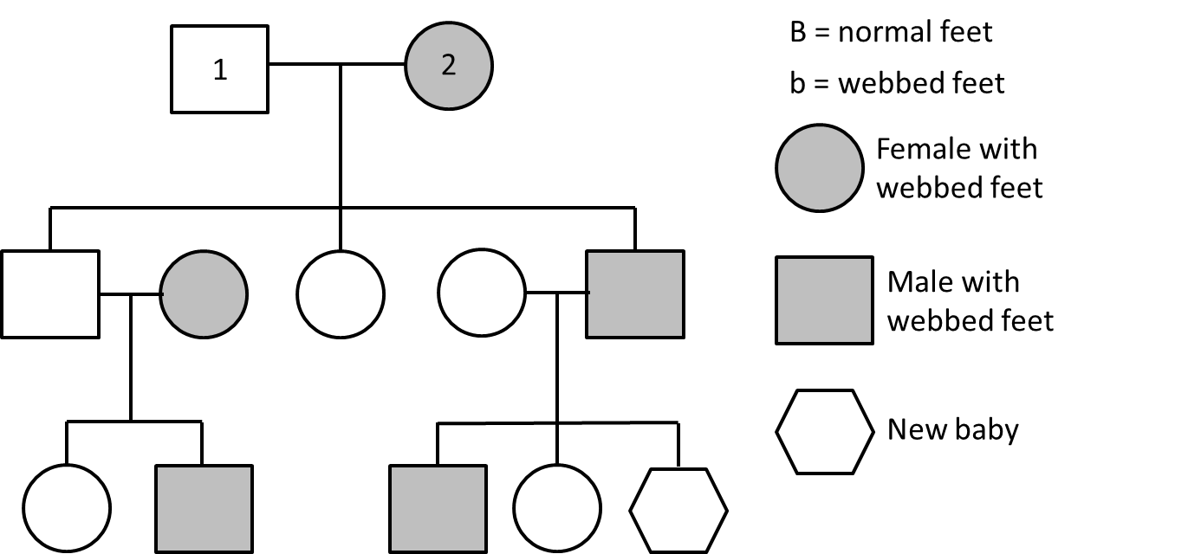

- Number the generations and each person on the pedigree.

- Fill out the following table by determining the pedigree of each of the listed individuals.
Person | Genotype
3
4
5
6
7
8
9
10
11

- What is the probability that the new baby will have webbed feet?

Part III
Read the scenario and draw a corresponding pedigree in the blank space provided.
Couple A has a son and daughter with normal skin pigmentation and another son who is albino. Couple B has one son and two daughters with normal skin pigmentation. The daughter from the Couple A has three children with the son from the Couple B. Their son and one daughter have albinism, and their other daughter has normal pigmentation.

