Using your knowledge of light provide the correct answers to the following questions. Make sure to completely answer each question and to show all of your work. Once you have completed the assignment, submit your responses to the dropbox.
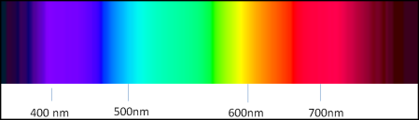
- What is your favorite color?

- Using the visible light spectrum picture above, what is the approximate wavelength of your favorite color?

- What is the wavelength of your favorite color in meters?

- What is the frequency of your favorite color?

- What is the energy in joules of one photon of your favorite color?

- What is the energy of a mole of photons of your favorite color?

