Using your knowledge of Bohr atomic models and the periodic table, provide the correct answers to the following questions. Make sure to completely answer each question and to show all of your work.
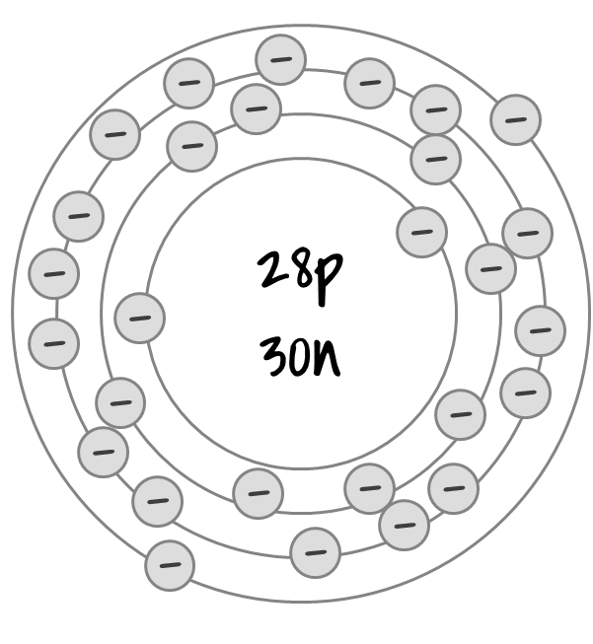
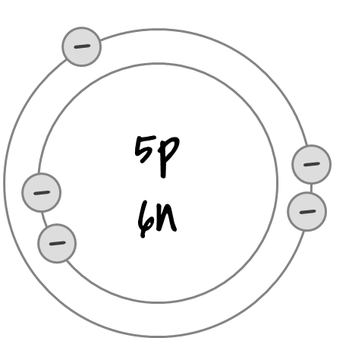
Part I
Use the diagram to the right to answer the following questions:
- Which element is represented? What is the element's chemical symbol?
- How many energy levels are present in this model?
- In which period on the periodic table is this element located?
- How many electrons are on the first energy level of this model?
- How many electrons are on the second energy level of this model?
- How many electrons are on the third energy level of this model?
- How many electrons are on the fourth energy level of this model?
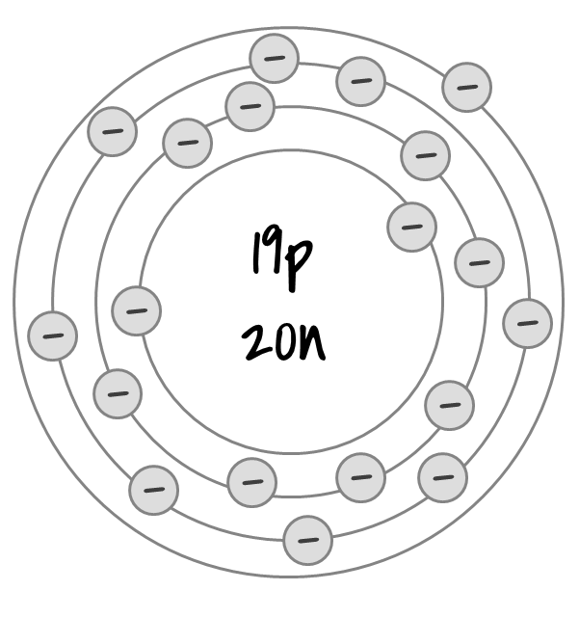
Part II
Use the diagram to the right to answer the following questions:
- Which element is represented? What is the element's chemical symbol?
- How many energy levels are present in this model?
- In which period on the periodic table is this element located?
- How many electrons are on the first energy level of this model?
- How many electrons are on the second energy level of this model?
- How many electrons are on the third energy level of this model?
- How many electrons are on the fourth energy level of this model?
Part III
Use the diagram to the right to answer the following questions:
- Which element is represented? What is the element's chemical symbol?
- How many energy levels are present in this model?
- In which period on the periodic table is this element located?
- How many electrons are on the first energy level of this model?
- How many electrons are on the second energy level of this model?
- How many electrons are on the third energy level of this model?
- How many electrons are on the fourth energy level of this model?
Part IV
- Based on what you have observed, how does the element’s position on the periodic table relate to the energy levels?

- Draw Bohr models for the following elements:
- Oxygen-16

- Helium-4

- Chlorine-36

- Calcium-40

