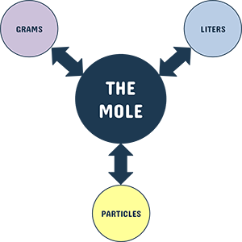
Now that you have learned how to complete mole applications, use dimensional analysis to provide answers to the questions below. Make sure to completely answer each question and to show all of your work.

1) How many moles are there in 24.5 grams of CoF₃?

2) How many molecules are there in 150.00 grams of Na₂SO₄?

3) How many moles are there in 2.3 x 10²⁴ atoms of sulfur?

4) How many grams are there in 7.40 x 10²³ molecules of PH₃?

5) How many moles are there in 7.5 x 10²³ molecules of H₂SO₄?

6) How many molecules are there in 55.5 grams of Cu(ClO₃)₂?

7) How many grams are there in 8.20 x 10²⁵ molecules of water?

8) How many molecules are there in 238.05 grams of CO₂?

9) How many molecules are there in 2.35 grams of NH₄F?

10) How many grams are there in 1.50 x 10²³ molecules of N₂H₆?

11) How many molecules are there in 20.40 grams of SiCl₄?

12) How many grams are there in 3.50 moles of AlCl₃?

13) How many moles are there in 4.50 x 10²² molecules of CH₄?

14) How many molecules are there in 9.34 grams of NO?

15) How many grams does 4.00 moles of UF₆ weigh?

16) How many moles are there in 230.0 grams of NH₄OH?

