Now that you have learned how to complete mass to mass stoichiometry, use conversion factors and dimensional analysis to provide answers to the questions below. Use the conversion factors provided to complete the conversions. Make sure to completely answer each question and to show all of your work.

Conversion Factors
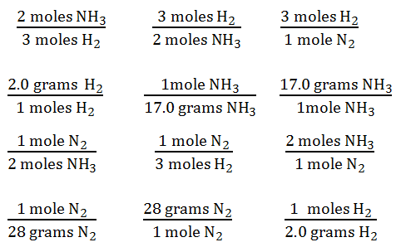

Conversions

- Convert 13.2 grams nitrogen to grams of ammonia.

- Convert 43.2 grams ammonia to grams of nitrogen.

- Convert 56.4 grams hydrogen to grams of ammonia.

- Convert 87.6 grams ammonia to grams of hydrogen.

- Convert 1.89 grams nitrogen to grams of hydrogen.

- Convert 3.89 grams hydrogen to grams of nitrogen.

