Measuring, graphing, and converting are all skills that you will need to become a qualified Earth scientist. It is now time to prove what you have learned about measurement by completing a series of tasks that involve measuring common objects, solving for density, and graphing. Make sure to completely answer each question, to show all of your work, and to include units of measurement.
Once you have finished the activity, please submit your responses to the dropbox.
Equipment and Materials
- Metric Ruler
- Cereal Box
- One food item with nutrition information
Measurement and Conversion
- Measure the height of your chair (floor to highest point) in centimeters. __________
  - Convert this quantity to meters __________
  - Convert this quantity to millimeters __________

- Determine the volume of a cereal box in cubic centimeters. __________
  - Convert this quantity to liters __________
  - Convert this quantity to kiloliters ___________

- Find a food item that has the mass listed in grams on the package. Name of item ___________
Grams_____
  - Convert to centigrams __________
  - Convert to hectograms __________

Mass, Volume, and Density
- Determine the volume of the cube below in cubic centimeters. __________

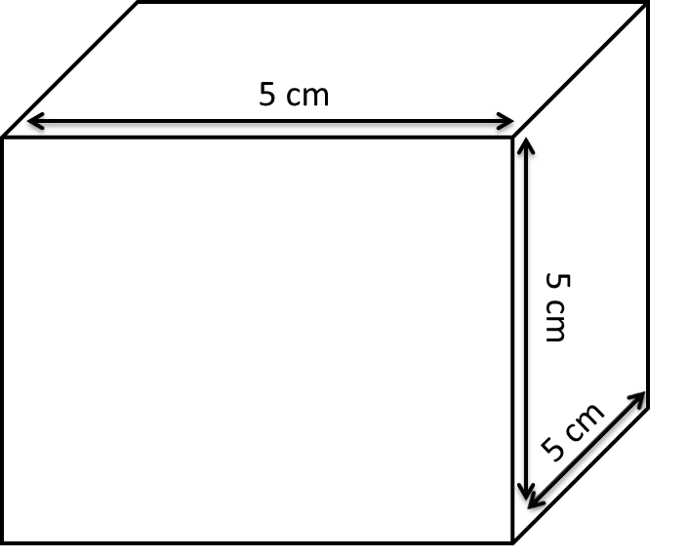
- Determine the volume of the cube below in cubic centimeters.__________
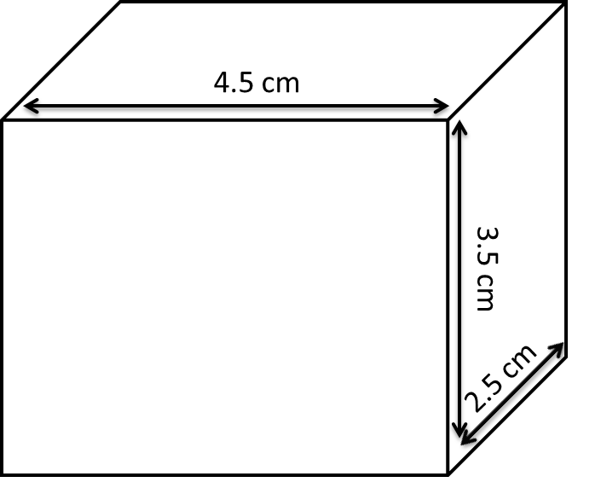

- A student performs an experiment with three unknown fluids and obtains measurements found in the table below. In which order would the fluids arrange when poured into a beaker? In the space provided below, sketch how these fluids would arrange in a beaker or graduated cylinder.
Fluid | Mass | Volume
Fluid A (yellow) | 2060 g | 2000 mL
Fluid B (blue) | 672 g | 850 mL
Fluid C (green) | 990 g | 1100 mL

Density Word Problems
Read the scenarios below and answer each associated question:
- Charlie has a graduated cylinder, water, and an irregularly-shaped object. He pours some water into the cylinder and records the water level at 57 mL. He adds the object and records the new water level at 90 mL. Prior to this, he had determined the mass of the object to be 157 grams.
  - What type of object does Charlie have: regular or irregular? __________
  - What is the volume of the object? __________
  - What is the density of the object? __________
- Katherine has an object that measures 18 cm long, 25 cm wide and 12 cm high. She places her object on a triple beam balance and it measures 125 grams.
  - What type of object does Katherine have, regular or irregular? __________
  - What is the volume of the object? __________
  - What is the mass of the object? __________
  - What is the density of the object?
Graphing
- Review the two data sets below. Determine which set is qualitative data and which data set is quantitative data. Create a line graph with the quantitative data set in the space provided, or use the digital graph paper provided in the Developmental Module.
Make sure your graph has:
- A descriptive title
- Both axes labeled
- Units of measurement
Data Set 1:
Element Name | Percentage of Earth’s Crust
Oxygen | 47.9%
Silicon | 28.9%
Aluminum | 8.3%
Iron | 5.2%

Data Set 2:
Distance from the Shore | Depth of Ocean
5 kilometers | 1000 meters
10 kilometers | 4000 meters
15 kilometers | 3000 meters
20 kilometers | 5000 meters

