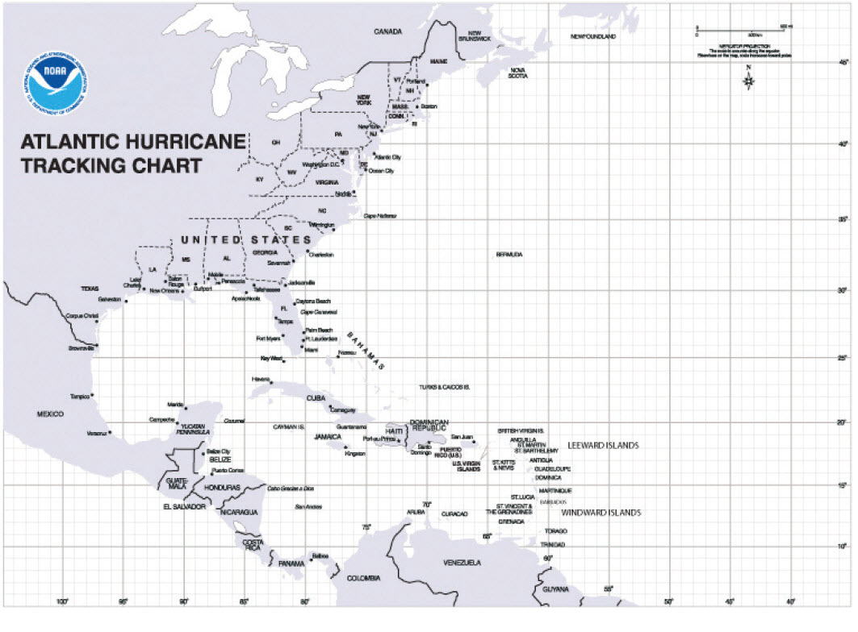
Data Analysis
After you have completed plotting the tracks of Hurricane Irene and Hurricane Katrina, answer the following questions in the blank spaces provided.
- In what body of water did Hurricane Irene form? In that body of water did Hurricane Katrina form?

- Describe the water temperatures of both the Atlantic Ocean and Gulf of Mexico on a yearly basis. Which body of water is warmer? Which boy of water is cooler?

- How does the temperature of ocean water affect the formation and strength of hurricanes?

- The two hurricanes you tracked, Irene and Katrina, took place around the same time in August. What are reasons that Katrina grew to a category 5 hurricane and Irene only grew to category three hurricane?

- Hurricane Katrina reached wind speeds of 140 miles per hour on August 29, 2005. Twenty-four hours later Hurricane Katrina only had wind speeds of 50 mph. What caused this dramatic drop in wind speed?

