On the graphic below, indicate where each of the following steps falls in the water cycle:

- Evaporation
- Condensation
- Runoff
- Infiltration
- Precipitation

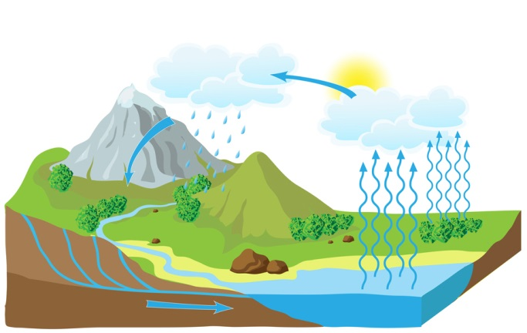

In this section, you will need to compose a one to two sentence description of each step in the water cycle.
- Evaporation
- Condensation
- Runoff
- Infiltration
- Precipitation

