Module 1: The Journey of Self-Discovery-Introduction to the Digital Portfolio
Module Assessment: Revealing Ourselves through Literature, Poetry, or Music

Decorate the shape below so that it reflects you and your chosen work. To decorate the image, draw and color over the shape. Then answer the questions that follow.
Please list your Literature, Poetry, Art, or Music choice: ______________________________

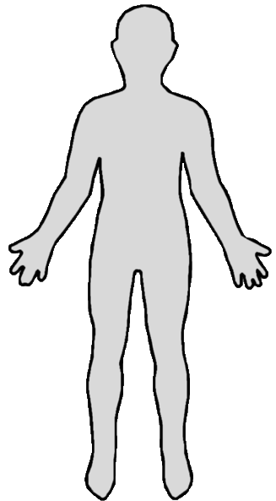
Questions
- Explain in a paragraph how the self-portrait and the chosen work represent you.

- Do you know of other works that could be used to represent yourself? If so, write a brief explanation of how other works could also be as a representation.

Reflection
- Did you learn anything new about yourself throughout this module?

