Module 7: Survival
Topic 3 Application: Mask Template and Checklist

Please decorate the mask below according to the instructions:
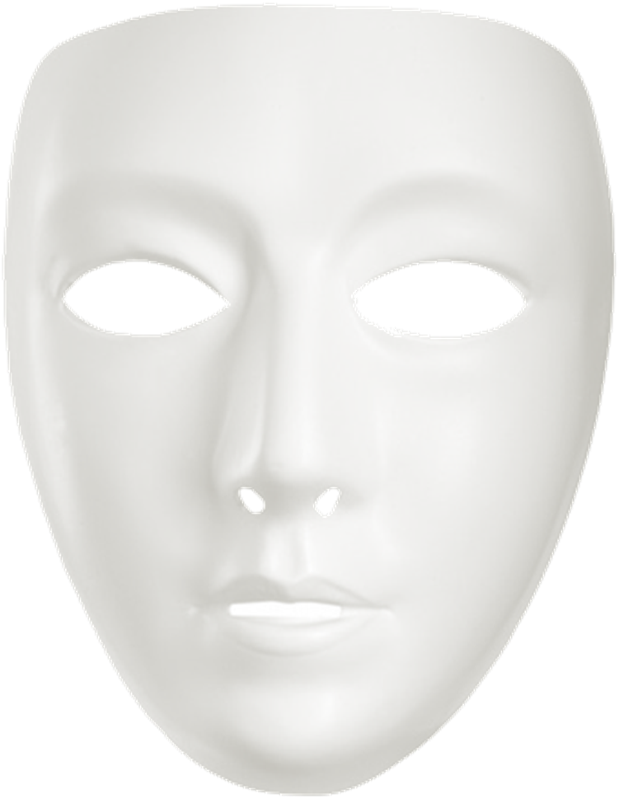
Checklist
Your mask should include all of the criteria listed below to receive full credit.
Included? | Item
 | Your mask clearly represents one of the characters.
 | Your mask contains decorations or paint that represents the character’s archetype.
 | Your mask contains decorations or paint that represents anything important to the character.
 | Your mask is both neat and creative.
If you use resources outside of this course to complete this assignment, please submit a Works Cited document. If you need assistance, visit the Developmental Module for information on citing any resources that you used.
Item
 | If resources outside of the course are used, a Works Cited document is submitted along with the assignment.

