What have you learned about the elements of Modernist poetry in your study of Robert Frost and Carl Sandburg? Take a moment to organize the information you have learned in a creative and organized way.

In the field of chemistry, the periodic table of elements is essentially a chart or table that organizes information about all of the known elements according to their atomic number. The shape and arrangement of the periodic table has changed since it was first created, and it continues to evolve as more elements are discovered. Although there is a standard periodic table, there also exist many variations in the arrangement of elements. Below is the standard periodic table that most chemists use:

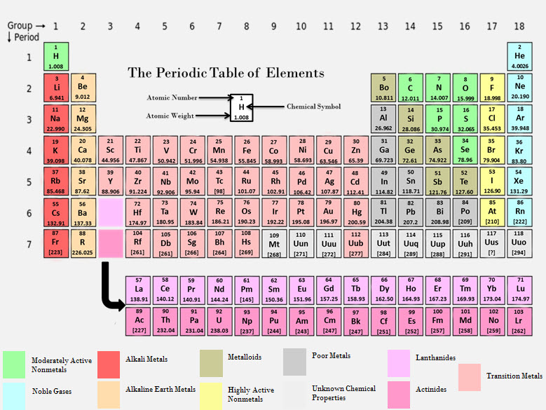

Each element is located within a cell or box and contains at least three pieces of information: the chemical symbol, the atomic number, and the atomic mass. The cell for hydrogen may look something like this:

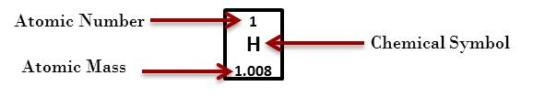

For this assignment, use your creativity and knowledge of Modernist poetry to design your own Modernist Poetry Table of Elements. You can arrange the elements of Modernist poetry in any way that you feel makes the most sense, but each cell must contain at least the following three pieces of information:
- The symbol for each element
- A brief summary or definition of the element in your words
- An example of the element in the form of a quotation from the poems in this topic

You are free to add any additional information to your table. If you decide to color code your table, please include a color key that explains the meaning of the colors. Before you begin, review the Modernist Poetry Table of Elements Checklist to make sure that you include all of the items required for full credit.

Once you have completed your table of elements, please submit your work to the dropbox.

Modernist Poetry Table of Elements Checklist

As you complete your table of elements, please review the checklist below to ensure that you have included all needed items.

Your submitted work should include all of the criteria listed below to receive full credit.
Included? | Item
 | You have created a table with the five elements of Modernist poetry.
 | Each cell in your table has the symbol of the element.
 | Each cell in your table has a brief summary or definition of the element in your own words.
 | Each cell in your table has a quotation from the poems in this topic that serves as an example of the element.
 | The information presented in your table is accurate and concise.
 | Your table uses correct grammar, spelling, and punctuation.

