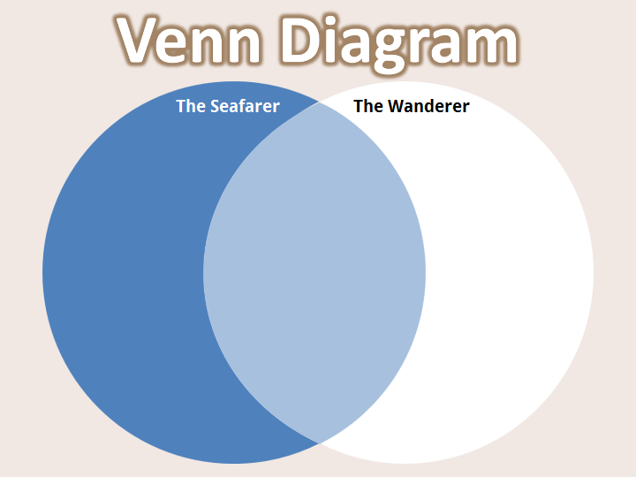

Read the descriptions of the protagonists from "The Seafarer" and "The Wanderer." Then, place each description in the correct place on the Venn diagram.

Does the description refer to the Seafarer, the Wanderer, or both?

- He is dominated by a sense of melancholy and pessimism.
- He is dominated by a sense of longing for freedom.
- He is surrounded by icy, frozen imagery.
- He believes that life amounts to nothing.
- He believes that one must accept fate.
- He laments the loss of land's worldly pleasures.
- He wants to leave the hypocrisy he sees on land.
- He struggles with loneliness and solitude.
- He lost many of his fellow warriors in battle.
- He wants to find a new home.
- He used to be wealthy.
- He used to be a sailor.

