Macbeth is not a play for the faint of heart. There are witches, ghosts, murders, hallucinations, and supernatural events. Now that you have read three of the five acts, summarize the most important, memorable plot events by creating a comic strip that reveals the main events and troubling changes that occur in Acts I–III.

Begin by selecting six quotations that clearly show how the plot is building in suspense and dedicate a panel or segment of the comic strip to each quotation. Within each panel, you must include an illustration of the scene along with speech or dialogue balloons that indicate who is saying what. Be sure to choose your quotations carefully since you will not be able to include every detail of the plot. Your quotation may include lines from several characters, but keep in mind that the passage must fit within a panel.

Underneath each panel, leave space for a caption that summarizes in your own words what is occurring in the scene. After the caption, indicate where in the play you can find the quotation by citing the act and scene. Observe the example of a panel below to get an idea of the required elements:

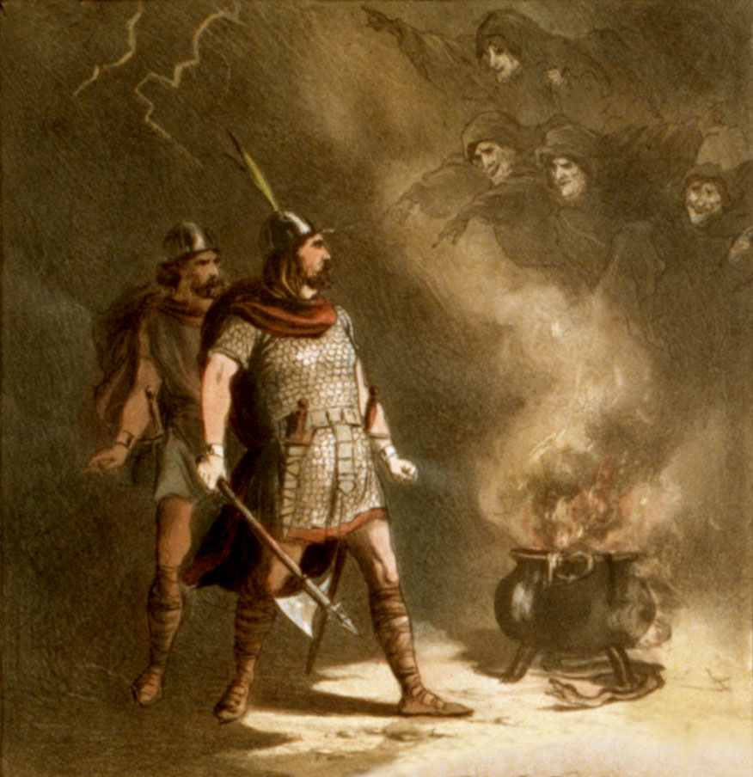
Three witches tell Macbeth that he will one day be king. (I.iii)

Options to create your comic strip include the following:
- Hand-draw the assignment and then take a picture of it for submission to the assignment's
dropbox.
- Hand-draw the assignment and then scan it for submission to the assignment's dropbox.
- Utilize a paint, publishing, word processing, presentation, or graphics software program to create
the assignment.

Before you begin, review the Macbeth Comic Strip Checklist to make sure that you include all of the items required for full credit. Once you have completed your comic strip, please submit your work to the dropbox.

Macbeth Comic Strip Checklist

As you complete your comic strip, please review the checklist below to ensure that you have included all needed items.

Your submitted work should include all of the criteria listed below to receive full credit.
Included? | Item
 | You have carefully chosen six quotations from Acts I–III of Macbeth.
 | You have dedicated a panel of the comic strip to each quotation.
 | Each panel has an illustration of the scene.
 | Each panel has one or more speech bubbles that indicate who is saying what.
 | Each panel includes a caption in your own words that summarizes the scene.
 | After each caption, you have cited the act and scene in the play where you found the quotation.

