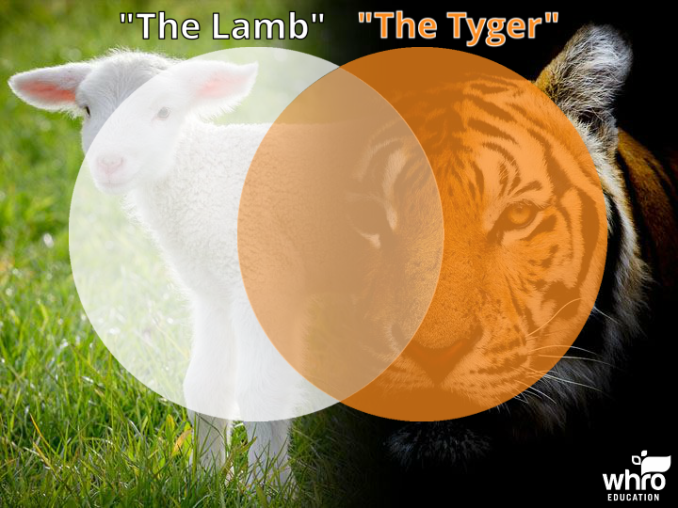

Read the descriptions of "The Lamb" or "The Tyger" by William Blake. Then, place each description in the correct place on the Venn diagram.

Does the description refer to "The Lamb," "The Tyger," or both?

This poem...
- ... portrays an animal as powerful and fearsome
- ... has an allusion to Jesus
- ... uses alliteration
- ... portrays an animal as innocent
- ... includes a speaker who questions the creation of an animal
- ... includes a speaker who understands the creation of an animal
- ... has a metaphor involving a blacksmith
- ... uses repetition

