Complete the Prewrite and Organize steps in this document on the prompt below:
Prompt: You have entered into a contest to win one million dollars. One of the requirements of the contest is to name the first three purchases you would make with this money and explain why. Be sure to explain your reasons clearly.
As you complete the prewrite and organize steps, refer to the checklist at the end of this document to make sure that you include all of the items required for full credit. Once you have completed your prewrite and organize steps on the POWER Strategy Organizer and Checklist document, please submit your work to the dropbox.

Step 1: Prewrite: Develop a list OR brainstorming web for the prompt above. You do not have to do both.
List

Brainstorm/Cluster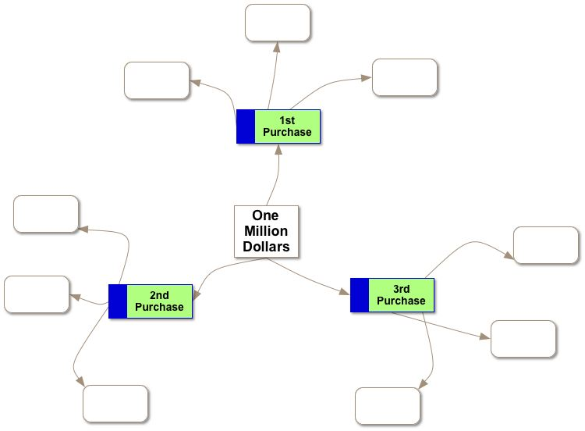

Step 2: Organize: Now, gather all of your ideas from the prewrite step, draft a working thesis statement, and put them together in an outline below.
Working Thesis Statement:
Subject:
Attitude/Position:
Topics:
Thesis:

Outline
Thesis Statement:
I. First Purchase
A.
B.
C.
II. Second Purchase
A.
B.
C.
III. Third Purchase
A.
B.
C.

Checklist:
As you complete the prewrite and organize steps of the POWER Strategy Organizer, please review the checklist below to ensure that you have included all needed items.
Your POWER Strategy Organizer should include all of the criteria listed below to receive full credit.
Included? | Item
 | Evidence of the prewriting process is provided.
A working thesis statement is provided. The thesis statement:
- Is debatable
- Includes three reasons or “becauses”
 | A relevant outline is provided for the prompt.
 | The information provided on the POWER Strategy Organizer demonstrates an understanding of the POWER strategy in writing.
 | The POWER Strategy Organizer is free from any spelling or grammar errors.
If you use resources outside of this course to complete this assignment, please submit a Works Cited document. If you need assistance, visit the Developmental Module for information on citing any resources that you used.
Included? | Item
 | If resources outside of the course are used, a Works Cited document is submitted along with the assignment.

