Illustrate the shape below so that it reflects the character as you think they appear at the beginning of the story. To illustrate the image, you may draw and color over the shape. If you would like to create your own character image with another piece of software, you may do so.
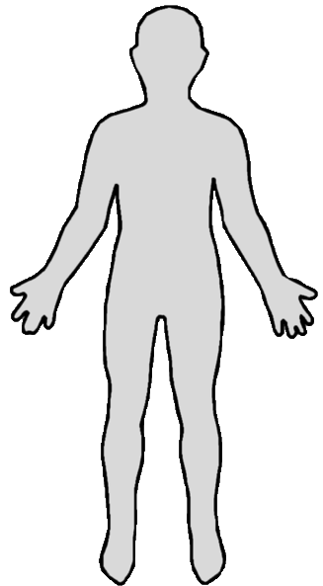

Questions
- Which character did you select?
- Is your character a primary or secondary character?
- Is your character a protagonist or antagonist?
- Is your character static or dynamic?
- Is your character flat or round?
Illustrate the shape below so that it reflects the character as you think they appear at the end of the story. To illustrate the image, you may draw and color over the shape. If you would like to create your own character image with another piece of software, you may do so.

