Part A
Label the following image with the appropriate French vocabulary terms.

- _________________________

- _________________________

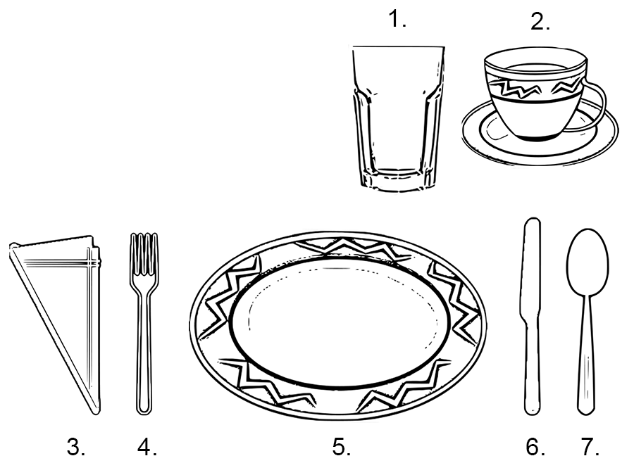
- _________________________

- _________________________

- _________________________

- _________________________

- _________________________

Part B
Now that the table is ready, write a conversation between a server and a customer in a restaurant. This conversation needs to be entirely in French and should consist of at least 10 lines of dialogue. The customer should get the server’s attention and ask for a menu. Then, the customer should place his or her order. Finally, the customer should find out how much the bill is. The server should respond appropriately and ask appropriate questions.

Customer ______________________________________________________________________

Server ______________________________________________________________________

_________ ______________________________________________________________________

_________ ______________________________________________________________________

_________ ______________________________________________________________________

_________ ______________________________________________________________________

_________ ______________________________________________________________________

_________ ______________________________________________________________________

_________ ______________________________________________________________________

_________ ______________________________________________________________________

