Throughout this topic, you learned that angles are formed by intersections of chords in the interior of a circle and angles are formed in the exterior of a circle by secants and tangents. Now it is time for you to apply your knowledge in this assignment. The following circles display several angle and arc relationships. Determine the unknown value in each circle. Show your work and write your answers in the blank spaces provided.
- Find the value of x?
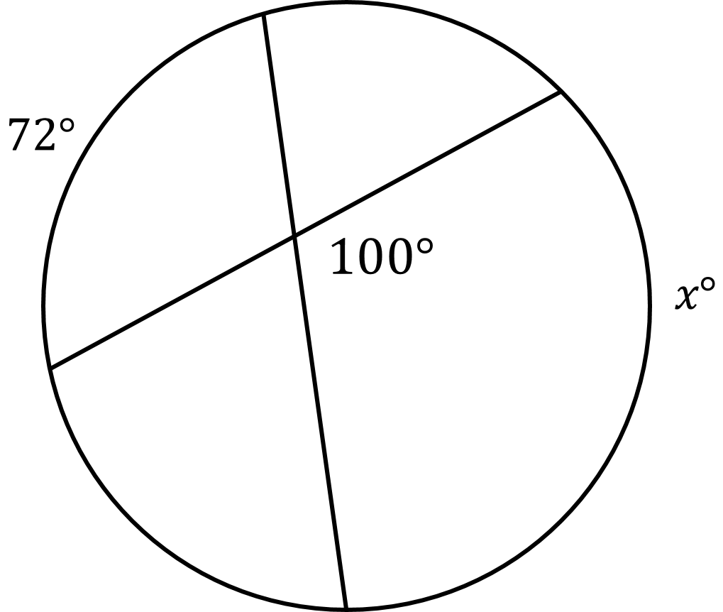

2. What are the values of x and y?
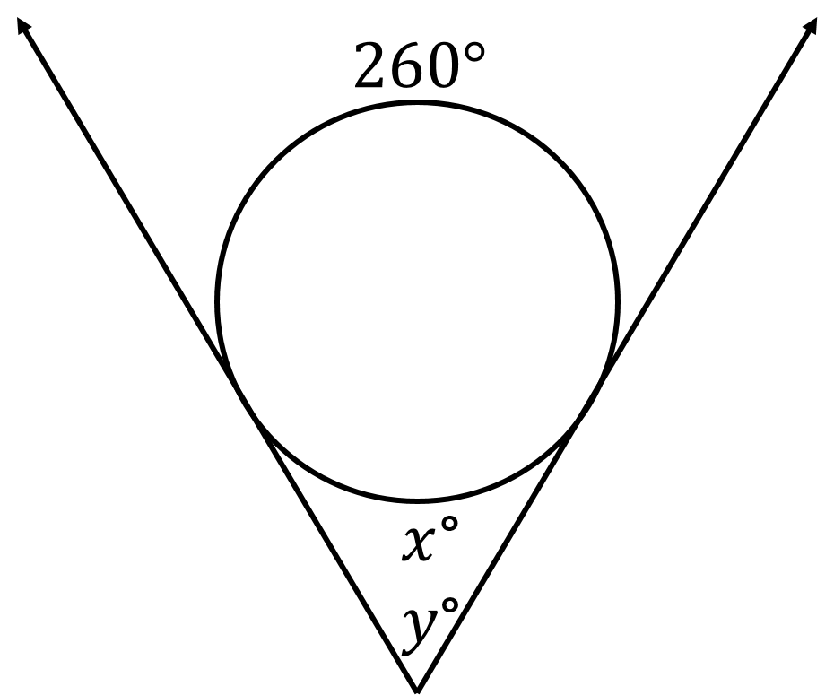

- What are the values of x and y?
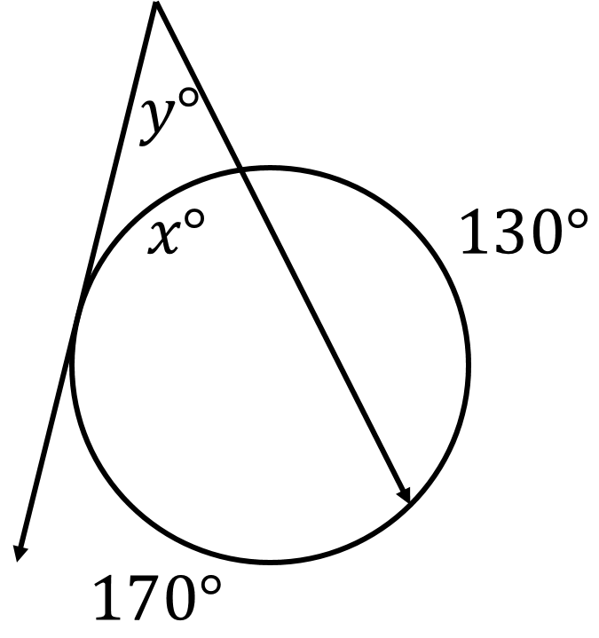

- What are the values of w, x, y, and z?
