In this topic, you explored central and inscribed angles. Now it is time for you to apply your knowledge in this assignment. Follow the directions below for each part. Show your work and write your answers in the blank spaces provided.
Part 1: For problems 1 through 6, find each unknown value.
1.
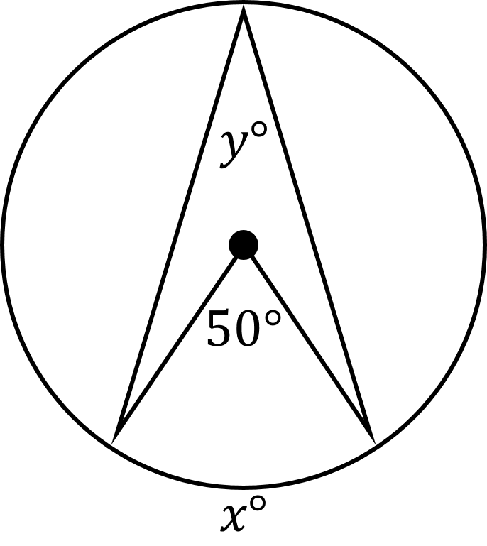

2.
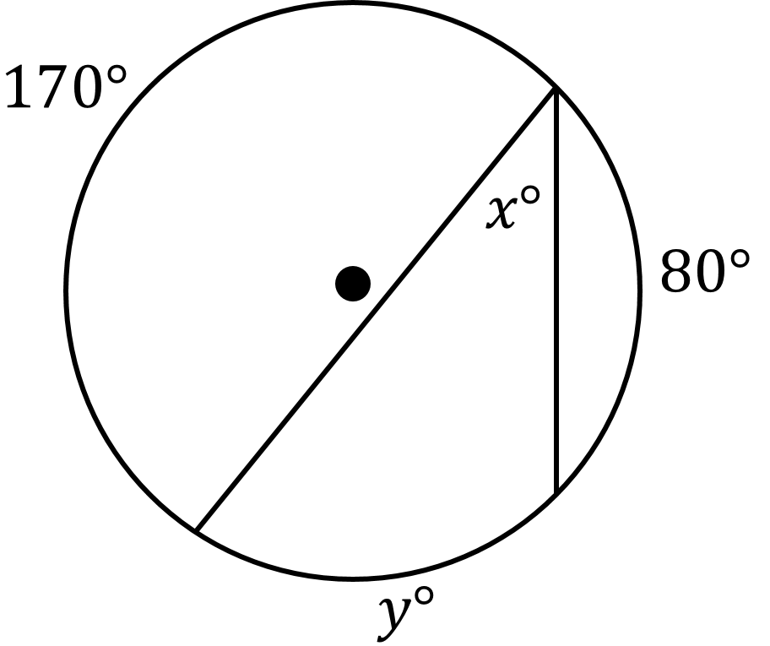

3.
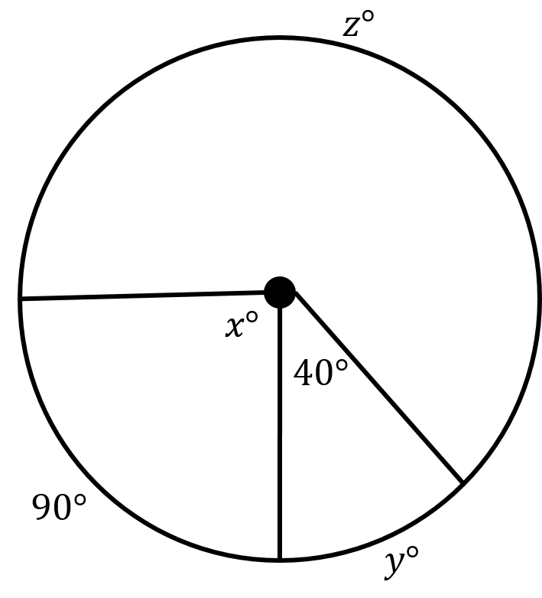

4.
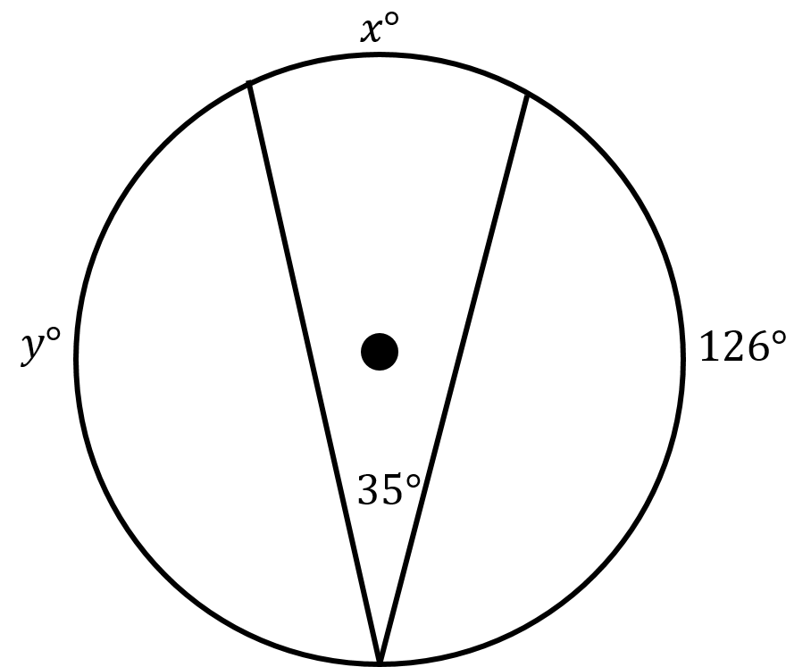

5.
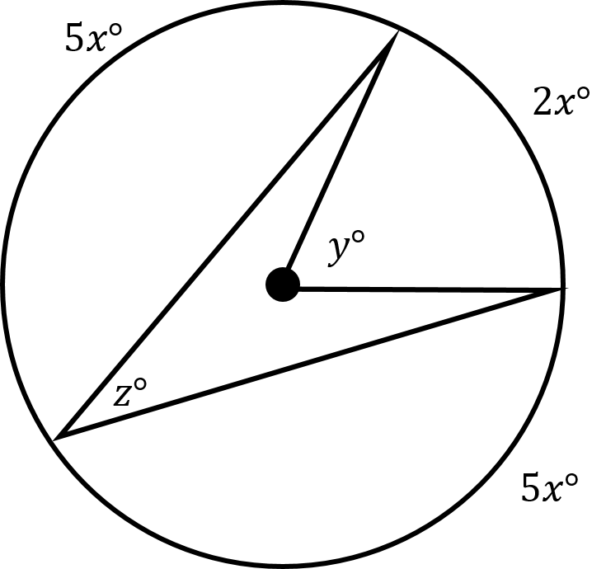

6.
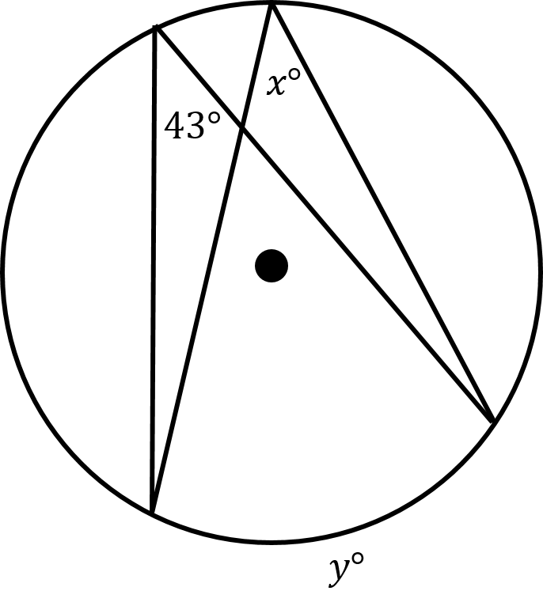

Part 2: For problems 7 and 8, find each indicated measure.
7. Given : ∠CGE is a right angle. Find m∠CGE.
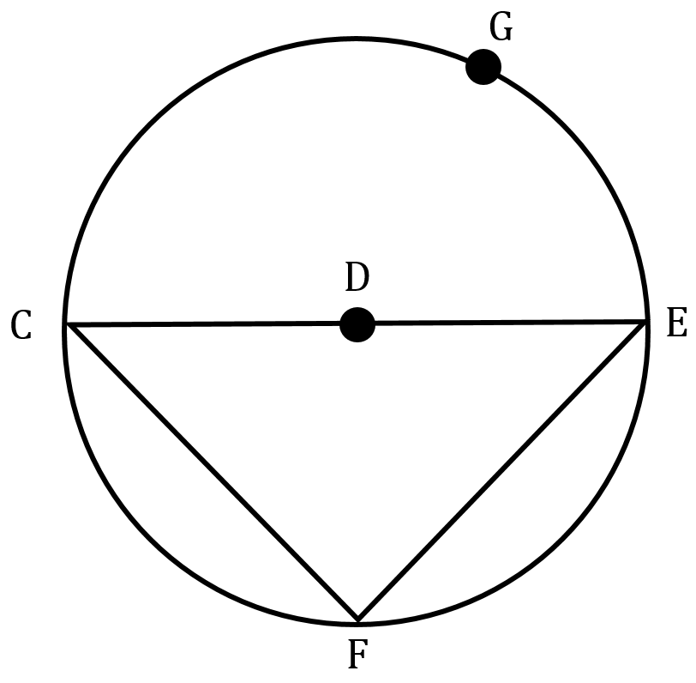

8. m∠PQR = ___________; m∠SQR =__________.
