Throughout this topic, you learned how to determine the volume and area of both cylinders, and prisms. Now it is time for you to apply your knowledge in this assignment. Follow the directions for each part and make sure to show all of your work.
Part 1: Use the diagram below to answer Questions 1-3.
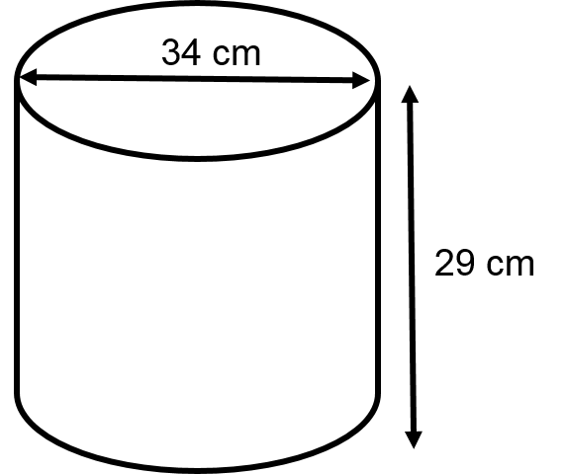
- What is the lateral area of the cylinder? Give you answer in terms of pi.

- What is the surface area of the cylinder? Approximate pi at 3.14. Round your answer to the nearest whole number.

- What is the volume of the cylinder? Give your answer in terms of pi.

Part 2: Use the diagram below to answer Questions 4-6.
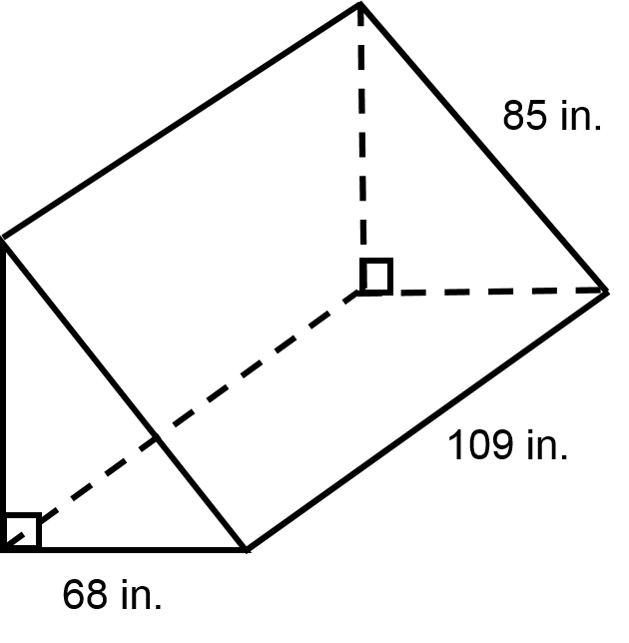
- What is the lateral area of the prism?

- What is the surface area of the prism?

- What is the volume of the prism?

Part 3: Use the diagram below to answer Questions 7-8.
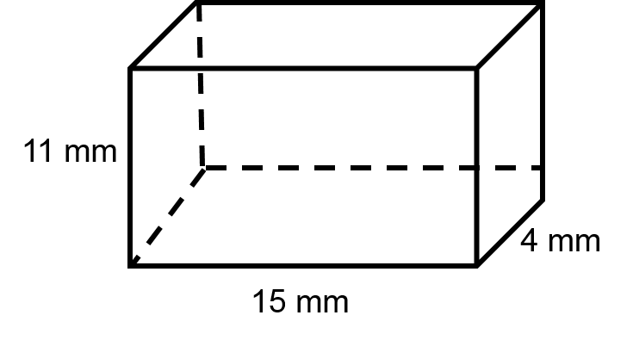
- What is the volume of the rectangular prism?

- What is the surface area of the rectangular prism?

