Throughout this topic, you learned how to determine the volume and surface area of both spheres and hemispheres. Now it is time for you to apply your knowledge in this assignment. Follow the directions for each part and make sure to show all of your work.

Part 1: Determine the surface area and volume for each sphere and hemisphere in Questions 1-8. Approximate pi to 3.14.
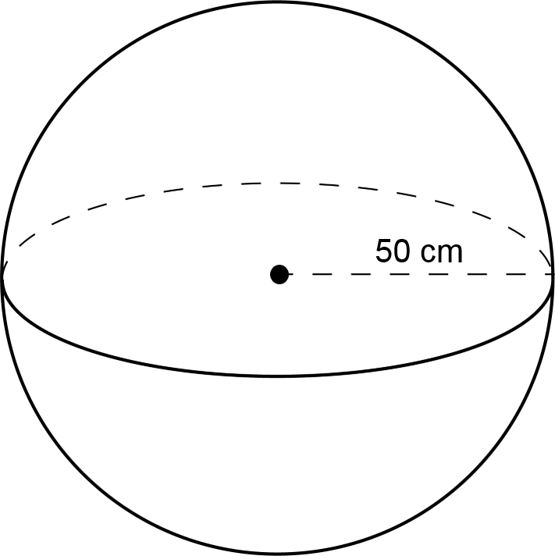

- What is the surface area of the sphere?

- What is the volume of the sphere?

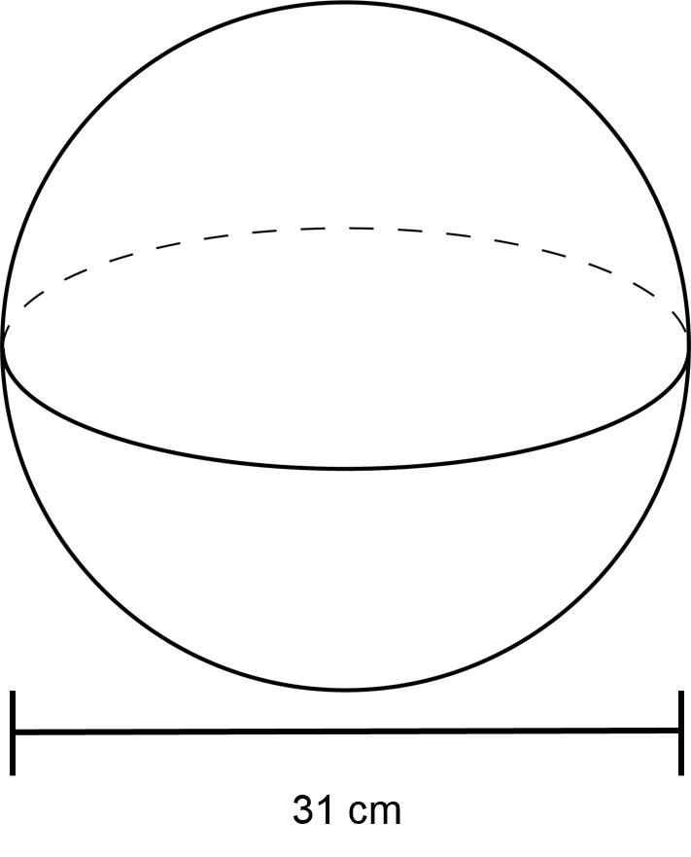
- What is the surface area of the sphere?

- What is the volume of the sphere?

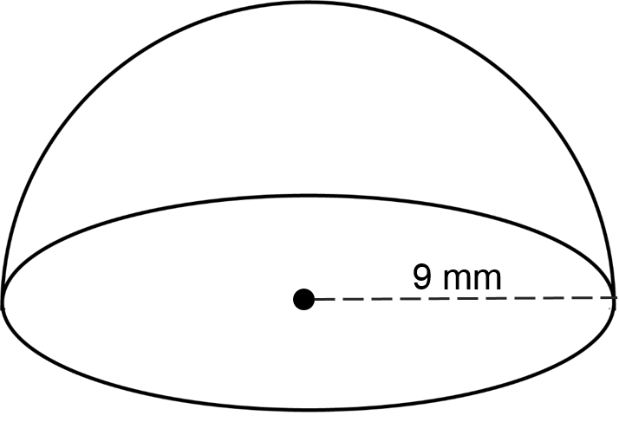
- What is the surface area of the hemisphere?

- What is the volume of the hemisphere?

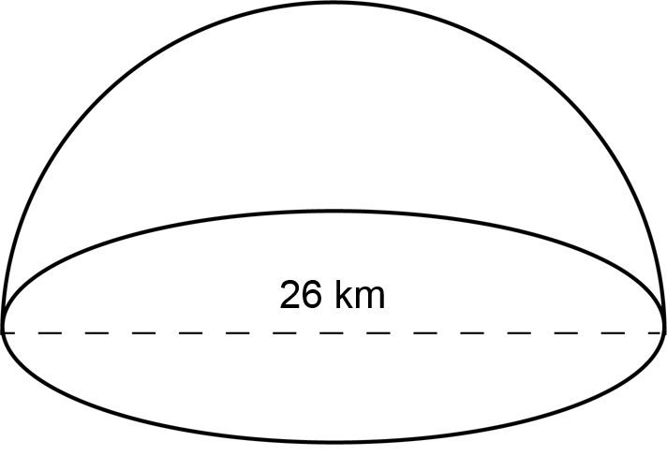

- What is the surface area of the hemisphere?

- What is the volume of the hemisphere?

Part 2: Answer the question and be sure to show your work for Questions 9-11.
- Explain the difference between the surface area and volume of a sphere.

- What is the diameter of a sphere whose surface area is square meters? Give your answer in terms of pi.

- What is the volume of a sphere whose surface area is square inches?

Part 3: For Question 12, explain the error in solving the following problem. Then, rework the problem correctly.

- A sphere has a diameter of 44 cm. Find its volume. Approximate pi at 3.14. Round your answer to the nearest whole number.

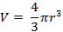

The volume is approximately cubic centimeters.

