Throughout this topic, you explored practical problems involving three-dimensional figures. Now it is time for you to apply your knowledge in this assignment. Follow the directions for each part and make sure to show all of your work.

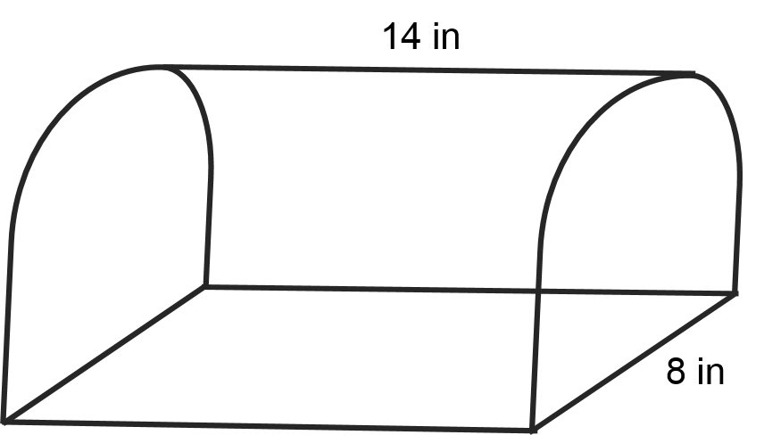

- Find the surface area of the figure shown. Approximate pi to 3.14.

- A fish tank has dimensions of 6 yards long, 4 yards high, and 2 yards wide. How much water would it take to fill it three-fourths of the way?

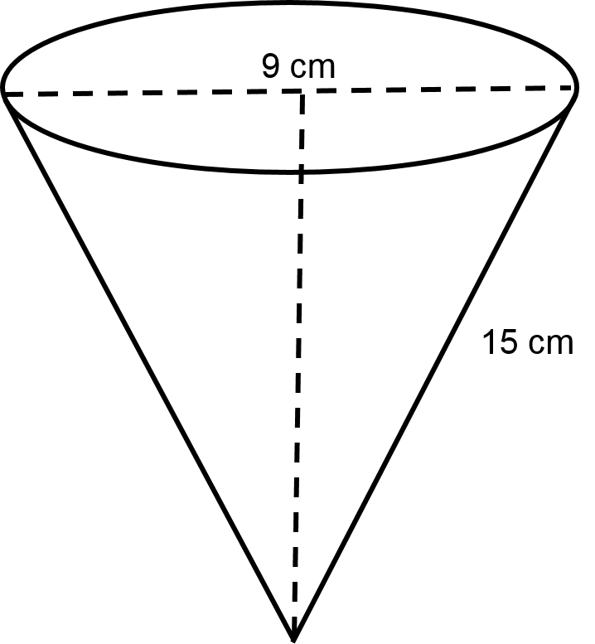

- How much ice is used to make the snow cone if the slanted height is 15 cm and the diameter is 9 cm? Assume the shape of the ice on top of the cone is half a sphere. Round you answer to the nearest tenth and approximate pi to 3.14.

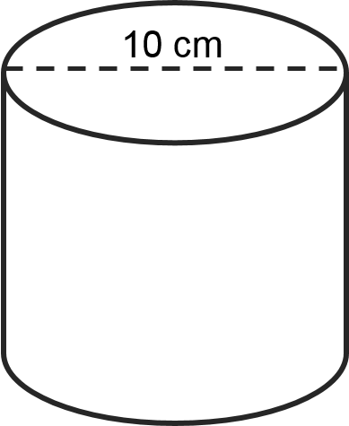

- How much paper would be needed to make a label for a can if the diameter is 10 cm and the height is two times the radius? Approximate pi to 3.14.

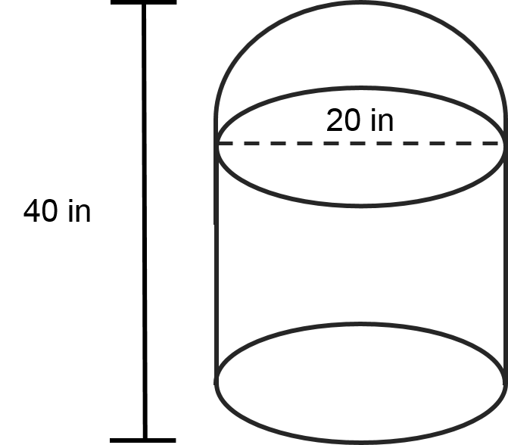

- Find the surface area of the figure shown. Approximate pi to 3.14.

